**eWALL Application and Services**

**(part 1)**



**This document presents the application and services implemented in eWALL that can be used by the eWALL Open Source Community. The document belongs to eWALL consortium and any use of the document requires the reference to eWALL Open Source (http://gitghub.com/ewallprojecteu)**

# Table of contents

Table of contents 2

1 Service bricks and applications: high-level view 3

1.1 Positioning in the eWALL architecture 3

1.2 End-to-end interaction flow 4

2 Service Bricks 5

2.1 Component view 7

2.2 Deployment view 9

3 Web Applications 10

3.1 eWALL Main screen 12

3.1.1 Authentication 13

3.1.2 The passive mode 14

3.1.3 The active mode 15

3.2 Daily Physical Activity Monitoring 16

3.2.1 Functionality Description 17

3.2.2 GUI Description 19

3.3 Daily Functioning Monitoring 20

3.3.1 Functionality Description 21

3.3.2 GUI Description 23

3.4 My Sleep Application 25

3.4.1 Background 25

3.4.2 Functionality Description 25

3.4.3 GUI Description 26

3.5 Healthcare monitor 29

3.5.1 Functional Description 29

3.5.2 GUI Description 29

3.6 Physical Trainer 32

3.6.1 Background 32

3.6.2 Functional description 33

3.6.3 GUI description 34

Bibliography 38

# Service bricks and applications: high-level view

The applications of eWALL offer the interface of the system to its users, either the end user at home, or the formal and informal caregivers. As such, their significance goes beyond that of a GUI; they are the endpoints where the intelligence and the personalisation of the system are exposed to the users.

The service bricks of eWALL provide the data to all the modules of the system. They offer the low-level data coming from the end user environment, which are a product of local context understanding (what can be observed in a single room of the home of a single user at a given instant of time), to the modules that perform reasoning (either at the given instant or across time). They also offer the data from the higher-level components, which now describe the full context understanding of the system (across space, time and possibly multiple end users), to the applications.

## Positioning in the eWALL architecture

Figure 1 provides a high-level view of the eWALL architecture and highlights the related positioning of service bricks and applications.

The left side of the figure represents the end user environment, which consists of the physical home where a display device and a set of sensing devices constituting a *sensing environment* are installed. The end user accesses the eWALL applications by means of a web GUI.

The components in the centre/bottom represent the lower-level backend components of the eWALL platform, dedicated to the collection, transformation, management and analysis of the data transmitted by the remote end user sensing environment:

1. Data retrieval is performed by a Cloud Gateway, which manages the connection to the home environments
2. Data storage and transformation is performed by a dedicated Data Management Block
3. Data analysis is performed by a set of Horizontal services.

The upper components on the figure represent the higher-level backend modules of eWALL, namely the service bricks (on the right) and the applications (on the left).

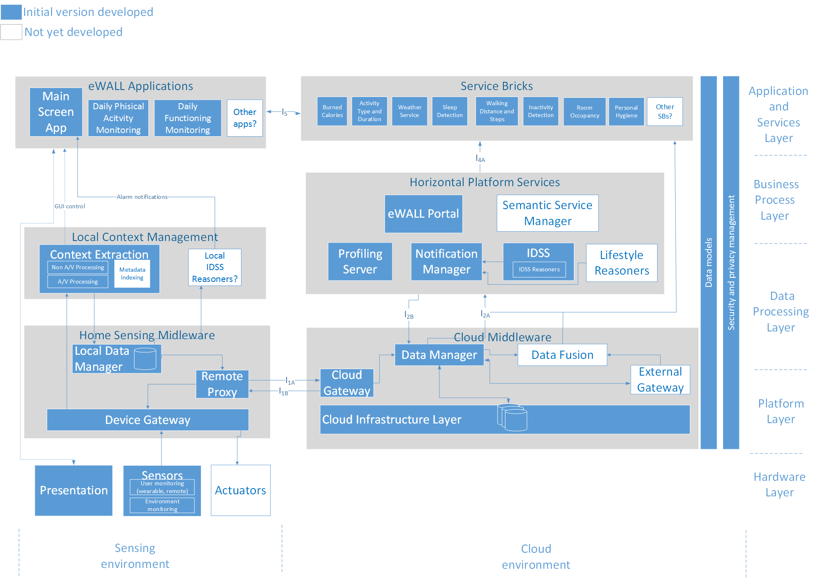

Figure 1: Positioning of service bricks and applications in the eWALL architecture (yellow and blue items)

The service bricks act as glue between the lower level components and the applications. They communicate:

1. with the Data Management layer and with the Horizontal services provided via a dedicated *southbound* API (I4A)
2. with the Applications via a dedicated *northbound* API (I5)

The implemented APIs provide at JSON [1]/RESTinterfaces and communication happens over the HTTP protocol; in the future, additional type of communication protocols (e.g. publish/subscribe interfaces) may be added [2].

## End-to-end interaction flow

This section describes by means of an example how the information in eWALL is collected and how it flows between the components from the end user sensing environment to the eWALL cloud, up to the service bricks and the applications, to be finally shown in a user friendly format on an application GUI.

To help with the example description, we refer to the diagram depicted on Figure 2, sketching the overall information flow in the eWALL system.

Our sample scenario consists of an end user at home, wearing an accelerometer that detects the user’s movements and transmits them (e.g. via Waspmote) to a Device Gateway, represented on the left side of Figure 2. The data, collected by the Device Gateway, are processed (transformed from signal processing measurements into a higher level metadata, such as IMA [3], ISAvalues or number of steps) and stored locally in a Home database. Then, they are transmitted via a Remote Proxy to the eWALL backend components running in the eWALL cloud. A Cloud Gateway (the central part of the figure) collects the data coming from the home and dispatches it to the Data manager, which stores it after applying proper formatting. The Data manager also offers an API to the other eWALL backend components to retrieve, update, and enrich the data.

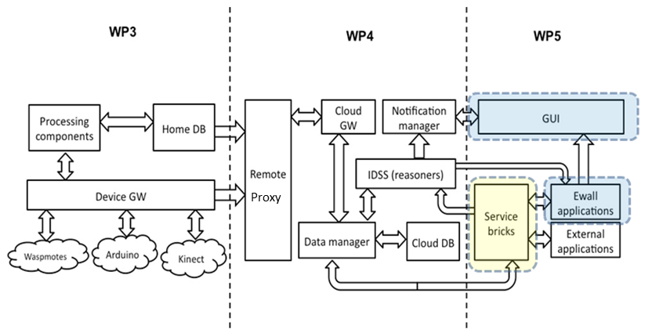

Figure 2: Sketch of the information flow in eWALL

The processed accelerometer data stored so far can then be accessed via this API by upper level components for different purposes:

1. The activity data can be analysed by reasoners that build short- and long-term activity models. The long-term models give rise to expected trends, either for the given end user, or for a number of end users in similar conditions. Deviations from these trends can be detected, either by the current activity behaviour, or by the short-term model. Combined with more information about the end user status and the urgency of the message, these deviations can trigger notifications towards the end user, such as motivational messages to perform more physical activity.
2. The activity data can also be collected on demand by service bricks, upon requests from the applications running at the end user’s home. As an example, the Daily Physical Monitoring Application (DPAM, cf. Section**3.2**) provides to the end users analysis of their physical activity performed over the time. The DPAM application queries the service brick for data related to a certain timespan. The service bricks, in turn, collect raw metadata from the Data manager, then apply algorithms that allow transforming such metadata into higher level data (e.g. burned calories, steps walked and type of activity) and send them back to the applications, which show them in the end user GUI in a user’s friendly format.

# Service Bricks

As mentioned in the introduction of Section 1, the service bricks of eWALL provide data to all the modules of the system, based on the analysis of the target end user’s local context. The analysis can be based both on real-time observations of meaningful parameters provided by the local sensors, and on aggregation of observations embracing specific timeframes.

Such context-awareness is transferred either to the eWALL modules which perform reasoning (cf. [4], [5]), or directly to the applications, that will use it to adapt GUI items on the user device or to provide information in the most suitable format for that specific user.

From the technical standpoint, the service bricks act as providers of specific context-related data, built by analysing and aggregating the raw information stored in the cloud Data Management Block, provisioned by the local sensing environments installed in the users’ homes. The eWALL applications and the reasoning modules (IDSS and Lifestyle reasoners) can retrieve such aggregated data from the service bricks via JSON/REST API calls over HTTP communication protocol. This stateless approach (no data are saved during request-response cycles) combined to the HTTP protocol is an architectural choice which enables scalability of the system and flexibility in the deployment scenarios.

The low-level metadata which feed the service bricks, is collected and sent to the Data Management Block by the home sensing environment, which gathers raw signal processing information and translates them into higher level metadata according to the eWALL architecture (documented in Deliverable D2.7 [6]).

The Service Brick architecture defined and implemented for the first phase of eWALL (documented in [5]) has been extended to address the shortcomingsfound during the first integration and testing phase, where slow performance issues were detected in the retrieval of data to be presented by the applications. A new type of service brick, “data-management” service brick, has been introduced to better cope with the metadata coming from the sensors through the Data Management layer. Such specialized service bricks are dedicated to the preparation of data for the applications, performing proper aggregations or transformation of information in advance and in batch mode. This data is then stored in a database specific to service bricks, and made available as “pre-digested” information to higher level service bricks, named “front-end” service bricks, which serve application upon request.

In addition to this, for optimizing the computational resources usage (minimizing the number of artefacts deployed on the application servers), the functionalities previously offered by separate service bricks were aggregated into a smaller number of larger service bricks, having in common the management of specific categories of metadata. We passed from a model based on many small services, each one providing a few endpoints, to a model based on a few services, each one providing many endpoints.

This Chapter specifies the currently available service bricks. For each of them, we describe how they contribute to add context-awareness to the overall system and which kind of intelligence is applied to participate in building advanced knowledge from raw data.

The level of intelligence applied by service bricks depends on the specific goal addressed. Some of them apply complex algorithms to produce new information, while other ones are much simpler and act just as data collectors and dispatchers on behalf of other eWALL components (e.g. the ones that perform Lifestyle reasoning).

In this section we also specify the aspects implemented so far and the ones expected in the next project cycles. After that, we give the technical description of the Apps interface, the Service engine and the Data Interface introduced in Section **2.1**.

As mentioned in Section1, the service bricks strongly depend on the raw data provided by local sensors. While in the first project cycle the service bricks where limited to the retrieval, analysis and manipulation of data coming from accelerometers, as this category of sensors was the first to be fully integrated in the eWALL platform, in the current phase they have been extended to manage also data provided by additional sensors in the system, being them real or simulated.This process allowed testing the functionality of the related service bricks using realistic, even if not live, data.

Finally, one specific service brick does not rely on data coming from sensors, rather it connects to external services to gather data based on the user context.

## Component view

As introduced in the previous section, service bricks fall into two categories: “front-end” service bricks, which expose the endpoint to applications and services, and “data-management” service bricks, which run in batch mode generating data and saving them into a dedicated database. The “front-end” service bricks use either information taken directly from the eWALL Data Management layer, or information that was generated by the “data-management” service bricks (by accessing the related service bricks database).

Figure 3 depicts the structure of a front-end service brick.

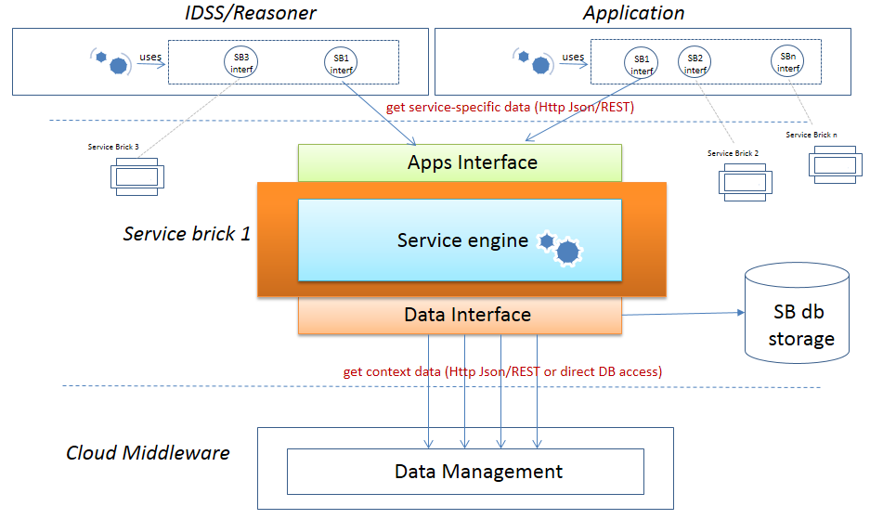

Figure 3: Component view of a “front-end” service brick

The front-end service brick is composed of the following software modules:

1. A northbound interface, named Apps Interface, which provides Http endpoints to be used by applications to collect the information provided by the service brick. The endpoints are managed by a controller module, which handles the Http requests with the related query parameters, checks for the correctness of the parameters and forwards the requests to the Service engine (see next point), waiting for data to be sent back to the applications.

2 . A *Service engine*, where the business logic of the service brick is performed. The Service engine receives the requests dispatched by the Apps Interface and applies the proper actions required to satisfy them. Typical actions consist of:

* 1. Getting data from the Data Management layer or from the service brick database: during this phase the service brickgathers pieces of information which allow to infer specific aspects of the user context, that will be used by the following reasoning process to build the output required by the application
  2. Applying some reasoning on such data: combining the gathered context-related data and applying to them dedicated computation algorithms which may involve the invocation of other eWALL services, the service brick generates the information required by the application
  3. Returning back such information to the Apps Interface: the data generated is transformed into proper representational format and sent back the requesting application, according to the specified API and communication protocol

1. A *Data Interface,* which consists of an API for data retrieval.The data access can be either towards the eWALL Data Management layer, or towards the dedicated service-brick database. In the first case, it queries the Data Access endpoints provided by the Data Management layer in the eWALL cloud and provides results back to the Service engine. In the second case, it queries directly the database to retrieve the data prepared by a data-management service brick.

Figure 4 depicts the structure of a “data-management” service brick.

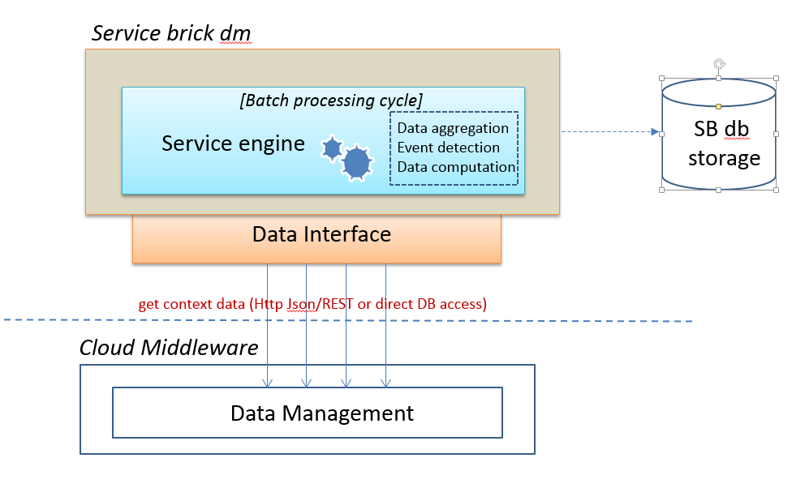

Figure 4: Component view of a “data-management” service brick

Such service is activated as soon as the hosting system is started, and operates autonomously with computation cycles which happen at scheduled intervals (with configurable frequency). At every iteration, the service queries the Data Management layer for new data (typically, new sensor data coming from the end user homes), and evaluates them to identify specific events and to apply detection algorithms to infer behaviours or states related to the end user. The result of such evaluations is stored in form of new generated information into the service brick database, and made available to front-end service bricks which can dispatch them to applications and services upon request.

## Deployment view

Every service brick is packaged and deployed as a *Java Web Application Archive*(war) [25]. This deploymentstrategy (see Figure 5) allows to leverage the benefits offered by *Java servlet containers*, which are standard, consolidated, enterprise-level runtime environments on which Java Web Applications (in our case the service bricks) can be deployed. Servlet containers provide high reliability and management features, which allow launching, stop and deploy applications independently. This allows, just to cite an immediate benefit, for *hot deployment* of applications, which basically means that it is not necessary to stop the whole application server (hence, stopping the provisioning of the services running on it) just to deploy a new service brick or an updated version of an existing one.

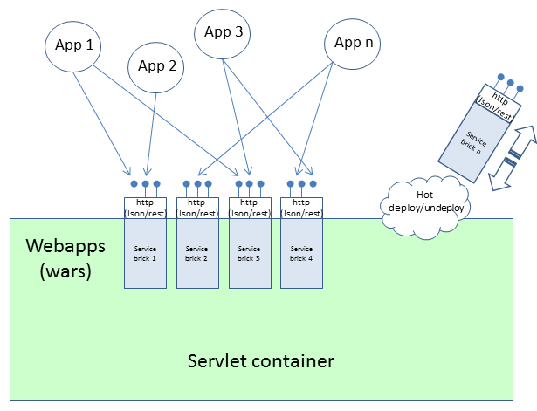

Figure 5: Deployment of service bricks

Once a service brick is deployed, the servlet container automatically activates it and the related endpoints are made available at the specified URLs for usage by the applications. If a previous version of the service brick was already present, the servlet container automatically un-deploys it and activates the new one.

# Web Applications

The applications are one of the core components of eWALL, as they provide the interface between the user and the system. Due to this, it is important to design them in a way that provides good quality of service and user-friendly interfaces.

The eWALL applications are web-based, meaning that they are designed to be executed and rendered in a web browser. The main reason for choosing this approach is that, being based on central hosting; it facilitates the applications maintenance, as it eliminates the need to distribute software to the end users.Another well-known reason for using web applications is their cross-platform compatibility. Since eWALL will support mobile platforms such as smartphones or tablets, the web application approach will provide universality in the design approach. From developers’ point of view, the readily available software from open source communities in the web applications development area makes them excellent candidates for rapid development.

The core technologies used to implement eWALL apps are: HTML5 [7], JavaScript [8] (JS), CSS3 [9](Cascading Style Sheets 3) and the Angular.js framework [10]. The fifth revision of HTML builds upon the success of the HTML4 [11]. It extends the previous one by introducing new input and multimedia controls. Furthermore, it is designed in a way that is compatible with older browsers and provides detailed rules for parsing, so it make possible that different but compliant browsers should provide the same results.

JavaScript is a multi-paradigm programming language supporting object-oriented, functional and imperative programming styles. It runs as part of web browsers and allows altering the content of the document, which is suitable for web applications. The scripts interact with the Document Object Model [12](DOM) of the page and are usually embedded into HTML pages. JavaScript runs locally in the user’s browser making the applications responsive to the user, which is a major advantage. Furthermore, it provides functionalities that HTML alone cannot provide. The scripts are running on interpreted and executed by the JavaScript engine.

To utilize asynchronous communication with the server, the eWALL applications are using the Ajax [13] technology, which allows for sending and retrieving of data without interfering with the page itself. In other words it is possible to update parts of the web page, without reloading the complete page.It is based on JavaScript, which turns it into a suitable design choice in the case of eWALL apps. Practice revealed that the more efficient format for communication between web applications is JSON, rather than other formats, such as XML [14].

Another development tool used in implementing the eWALL apps is jQuery [15]. It is a JS library used to manipulate DOM in an easy way. It wraps common tasks, consisting of many lines of code, into methods that can be called in a single line. One of the advantages it provides is the way it handles events in JavaScript. Instead of using HTML attributes to call JS functions, jQuery allows event handling to be done completely in JavaScript. Furthermore, it simplifies the usage of Ajax functionalities.

CSS is a language used to describe the formatting of a HTML document. It allows to separate presentation instructions from the HTML content in a separate file or style section of the HTML file. It is a core technology used for designing visually pleasant web applications. In eWALL, CSS revision 3 is used for the implementation of the applications.

Angular.js is a development framework which allows creating dynamic, flexible HTML applications, providing a toolset for wrapping/handling all of the above mentioned technologies in a uniform, simplified way. As it allows creating very dynamic views for the applications, it is particularly suited for the eWALL needs since a main aspect of the eWALL applications is the personalization of the interfaces based on the user needs.

The eWALL applications follow the standard design pattern model-view-controller. Generic block diagram, and system interaction is depicted on Figure 6.

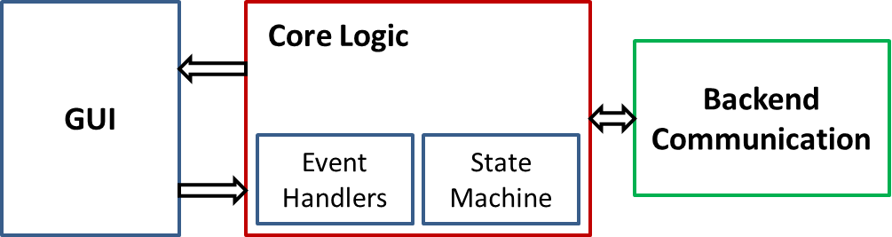

Figure 6: Generic view of eWALL web applications

The GUI block provides the interface between the user and the system. It includes GUI components used for displaying information and allowing the user to control the application. The GUI is built using JS and the formatting is done using CSS3. The Core Logic represents the controller part of the design pattern. It includes state machines for controlling the state of the application and event handlers for handling user input. The Backend Communication block carries the communication with the backend components such as service bricks and reasoner. It is utilizing the Ajax toolset and represents the data model of the design pattern. The communication is carried over HTTP protocol using JSON messages.

The applications are deployed into a Tomcat 7 [16] servlet container, on a dedicated Ubuntu 14.04 [17] virtual machine running in the eWALL cloud. Indeed, a servlet container is not strictly required for running the eWALL applications: being HTML applications, a simple web server like Apache [18] would be enough. Anyway, for the first eWALL prototype, it was opted to use as deployment target the same server where the service bricks (which require a servlet container) are deployed. In the next phases, a dedicated web server will be set up for hosting the applications.

Each application can be accessed using public URLs having the format:

[http://[endpoint_url]/[app_abrv]/](http://[endpoint_url]/%5bapp_abrv%5d/intex.html)

Where [endpoint_url] is the server domain name and [app_abrv] is the abbreviation of the application (note that [app_abrv] is case sensitive). Indeed, the access to applications for the eWALL end users is wrapped by the main GUI (cf. Section 6.1).

New versions of applications are deployed simply by uploading the HTML code into a dedicated server folder without additional intervention. This allows for hot deployment and better quality of service.

Figure 7 depicts how applications are deployed to the hosting container. The application deployment model is the same as the one described for the service bricks in Section 2.2. The figure represents indeed two alternative deployment options. The first option implies a dedicated web server (shown on the right-hand side) for the applications, and a dedicated servlet container (on the left-hand side) for the service bricks. The second option (the one currently adopted) is represented by the dotted grey rectangle area, which indicates a single servlet container, where both service bricks and applications are deployed.

In both cases, the communication happens via JSON/REST over HTTP. Dotted arrows show, for each application (same dotted arrow colour), the interaction with one or more service bricks.

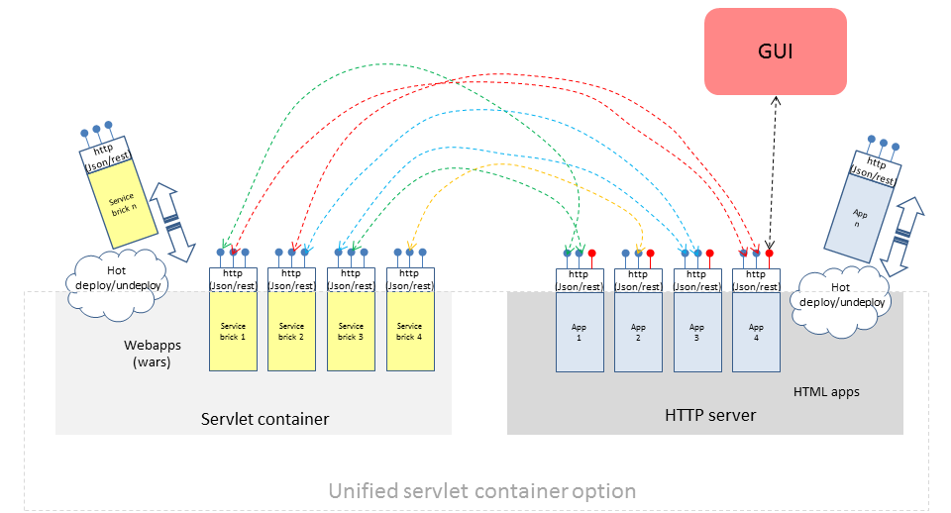

Figure 7: Deployment schema for applications and service bricks

## eWALL Main screen

This section defines the metaphor of the main screen user interface, describes the concepts behind the eWALL main screen, as well as its implementation particularities.

The eWALL main screen has the purpose of supporting the eWALL widgets and applications. It offers a space and context of interaction, through which the end-user can view and interact with the eWALL applications. It can be defined as an operating system user interface, specialized and personalized by the user’s profile data. The main screen acts as a ”container” for all the applications and GUI elements exposed to the end user. Indeed, in addition to the visual aspects, the main screen implements behind the scenes a set of horizontal functionalities which allow applications to interact in a secure way with the remote side of the eWALL platform, and that provide personalization of the GUI based on the user profile and remote service configuration.

Due to below average usability scores reported by all testing partners during small scale evaluations with elderly users, as well as usability and domain experts, the eWALL metaphor was redesigned, taking into account new participatory design requirements. These requirements resulted from the user test analysis and the evolution in the application development, which gave access to a more clear view of the sum of eWALL functionalities.

The new metaphor is addresses the user in a more casual and comfortable way. Its visual language removes: the classification complexity, ambiguous representations of triggers and feeling of empty interface.

a) 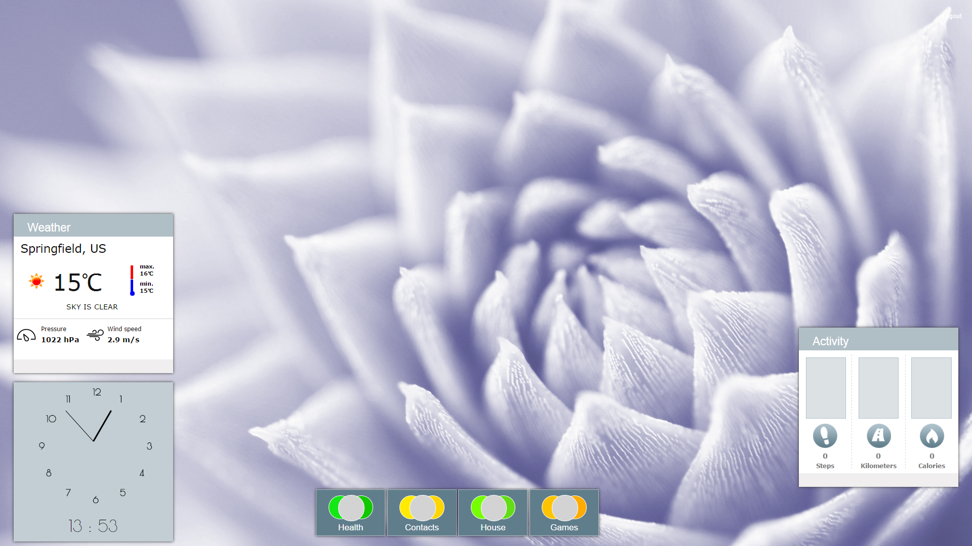 b) 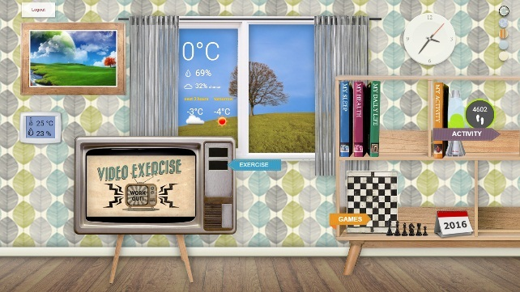

Figure 8: The main screen redesign outcome: (a) the previous main screen prototype, (b) the new main screen prototype, as resulted from implementing participatory design requirements

The new main screen metaphor implements a smart living room (cf. Figure 8(b)) which allows the user to interact with meaningful representations of eWALL applications as follows. Skeuomorphism [19] is the design principle behind this change. Also the language of eWALL has changed from the complex scientific formulations to a story telling language register. The new language was used with success in user tests as well. For example, in order for a user to understand how much physical activities he performed in the present day, in the previous prototype the user would have to perform the following task:

“Touch the Health category in the main screen menu. Touch the Daily Physical Activity application.”

In the new metaphor, eWALL writes the user's life in several books, much like an automatic journal. The new task a user will perform is:

“Touch the My Activity book, from the book shelf.”

In the following sections we will describe the essential functionalities of the main screen: the user authentication, the active mode, the passive mode.

### Authentication

The mainscreen is responsible for authenticating its user. Based on credentials generated during the registration phase of the user in the system, the mainscreen takes care of the interaction with the server-side eWALL authentication service to log the user into the system (cf.Figure 9).

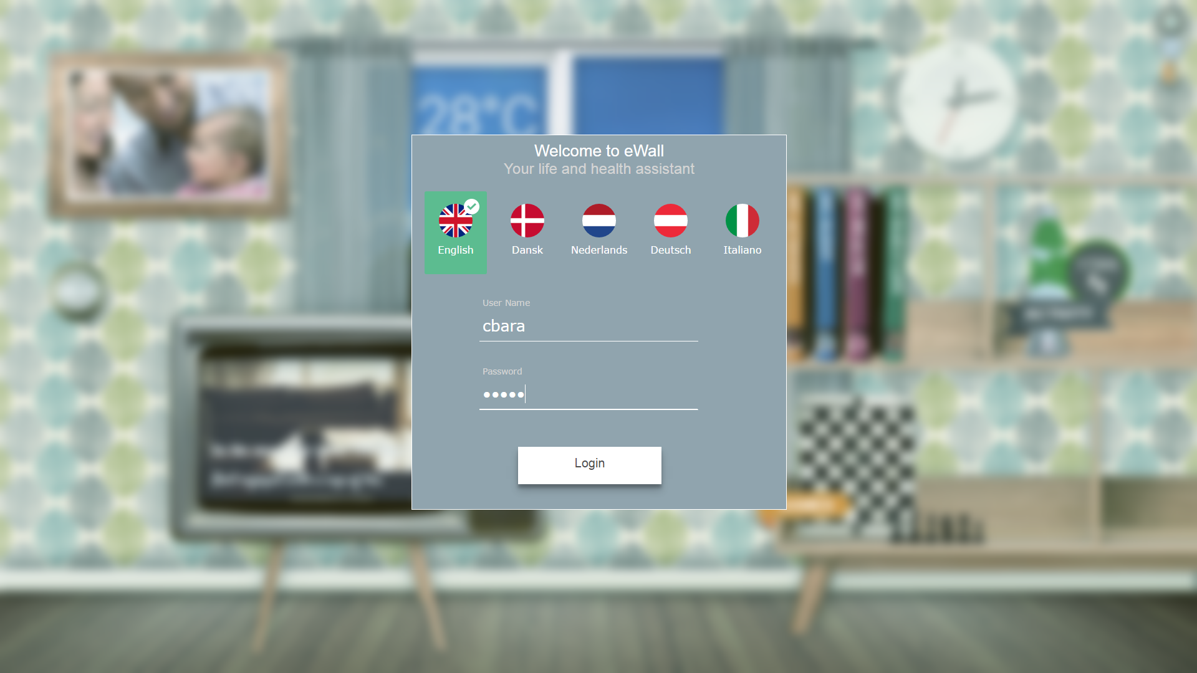

Figure 9: the eWALL main screen login mask

During authentication, the credentials and language preference, transmitted to the central system, are checked for validation. If validated, the authentication service retrieves the user profile from the Data Layer and checks for the set of services and applications which have been assigned to the user (by means of the eWALL Administration Portal, cf. [20]).Based on this set of information, the authentication service provides back to the mainscreen and authentication token (an encoded string) containing a lot of information among which the set of applications enabled for that user. In turn, the mainscreen, by decoding the token, creates dynamically visual elements which allow the user to interact with the related applications (e.g., it renders on the screen buttons for activating applications). If a change is made on the user profile through the Portal (e.g. an application is added to the set of allowed applications), a new button is shown on the screen. This is an example of personalization and of adaption of the user interface to his/her profile. As the token has a limited lifetime, the mainscreen also takes care if its renewal. Based on the expiration date, it triggers requests toward the server to renew it before it expires according to configurable policies, hence maintaining it alive for the whole duration of the mainscreen session. The token is the key to access the eWALL services, and must be sent at every request towards the service providers. The mainscreen hides to the applications the technical complexity of the token management and transmission, exposing a common library which wraps all the remote calls, allowing applications to interact with the eWALL services in a simple and transparent way.

For ease of use and security reasons, after the first successful login, the mainscreen remembers the language choice and user name. The next time, the user needs to log into the mainscreen she/he will only need to insert her/his password.

Conceptually, the main screen is integrated into the eWALL through its metaphor of smart living room. The smart living room reacts to user proximity to the eWALL screen, switching from passive mode (a reduced functionality mode) to active mode (fully functional screen).

### The passive mode

The smart living room zooms in to its left part, in case the user is not within the interaction distance of the screen (user cannot touch the screen). We call this the *passive mode* (cf.Figure 10). The interaction distance maximum 1.5 meters from the screen. No user interaction request is permitted by the main screen or subsequent widget and apps hosted on the main screen. Only a reduced set of widgets are exposed when the main screen is passive and they only display information (e.g.: the current time, the current weather, etc.).

It is envisioned that the passive mode will support most of the wellbeing advertisements, by displaying illustrated healthy living recommendations. We foresee this screen mode to be most prevalent throughout the day. Principles of print advertising are used for increasing adherence through positive psychology motivators. For example, eWALL advertises going to sleep at a reasonable hour by displaying a representative illustration.

The wellbeing advertisements will be easy to understand. Adherence to the recommendations is inferred from the sensor detection and continuous intelligent adaptations to the user’s behavior will increase a higher recommendation adoption.



Figure 10: Main screen in passive mode

Furthermore, the weather and ambient measurement widgets are displayed, as well as a an enlarged photo frame, which is connected to social media channels and configured so as family and friends can send pictures to this widget. The photo frame will loop through the pictures.

### The active mode

When the user is within the interaction distance for the screen (user is able to touch the screen), the screen switches to its *active mode* (cf.Figure 11). The active mode allows access and visibility to the widgets and application launchers.

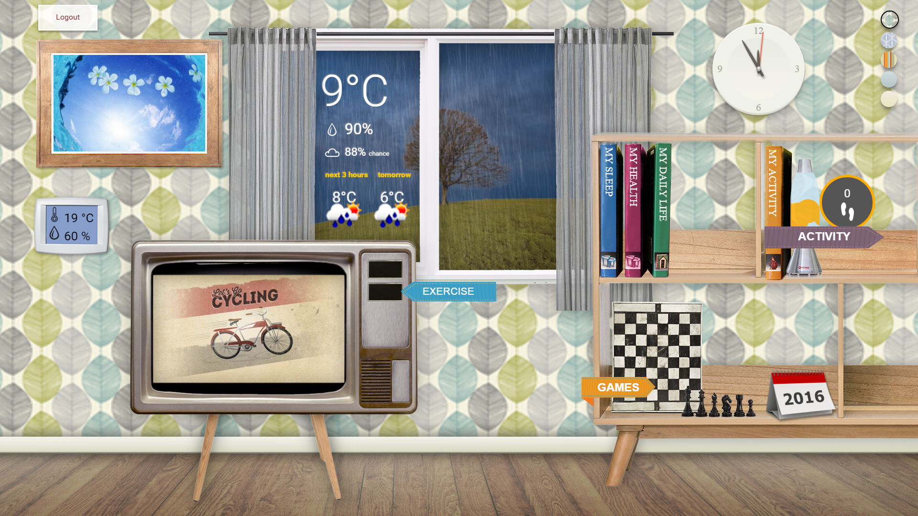

Figure 11: Main screen in active mode

Having such a large display area and a fixed location for using eWALL implies a specific user mindset. Using skeuomorphism, the smart living room will allow higher affordance when it comes to accessing eWALL functionality.

The applications are launched by taping on items, or part of the objects in the living room. The items are designed to be suggestive to the application they trigger. For example: monitoring application are triggered by books, the video exercise application is triggered by touching the corresponding EXERCISE button on the TV. The dommotics application is triggered by touchng the thermostat widget.

Games have a dedicated panel (the chess board) which contains a grid of chess items, each with a label and triggering a specific game.

In the following chapters we will explain, in detail, each item on the main screen living room.

## Daily Physical Activity Monitoring

One of the most important factors for the health living of elderly people is their regular physical activity. The Daily Physical Activity Monitoring (DPAM) application is web based application intended to provide to the user information about their daily activities such as walking, jogging, and exercising. It is a monitor in a sense that it displays in different metrics, how active the user was for selected day, week or a month. This feedback can be a reason or a motivation for the user to take necessary actions in case there was not enough activity during some period of time.

Using this application the user has the possibility to follow his progress, how much he walks in a given time period, how many calories he burned, or if he reached the designated goal for the day. Additional statistics on his different types of activities are provided. Based on these the user can decide upon necessity of increasing different physical activities such as running or exercising. The application can also serve the caregivers where they can use it to track the physical activity to their beloveds.

### Functionality Description

The application is web-based and is implemented in JavaScript, using jQuery and CSS3. It is designed in a way that is suitable for touch screens, which are the targeted devices in the eWALL project. The application adheres to the eWALL application model, utilizing Service Bricks (SB) and IDSS reasoner in order to collect the necessary information. The information exchange with the backend is request-response based via HTTP/REST interface as displayed on Figure 12. Usually the applications requests information for some time interval and desired aggregation period if applicable.

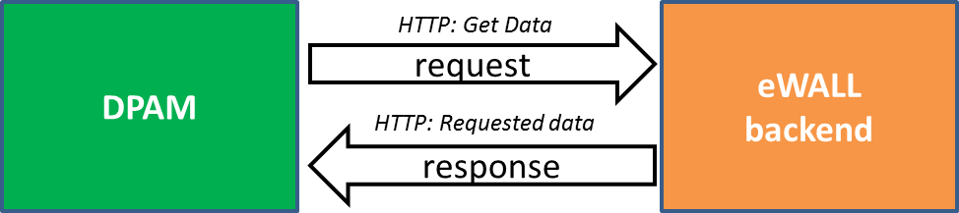

Figure 12: Simplified communication between DPAM and SBs

Detailed list of the utilized eWALL backend components is listed in Table 15.

|  |  |
| --- | --- |
| *Backend Component* | *Utilization* |
| MOVEMENT,  Physical Activity SB | *The application connects to this endpoint of Physical Activity Service Brick to extract information about steps, calories and kilometers for desired time interval and aggregation period* |
| PHYSICAL ACTIVITY, Physical Activity SB | *The application connects to this endpoint of Physical Activity Service Brick to extract information the type of physical activity the user was performing as well as the intervals.* |
| IDSS Automatic Goal Setting Reasoner | *The information provided by this reasoned is the goal in terms of steps the user have to achieve for a day.* |

Table 1: List of backend components utilized by DPAM application

Trough connection to the listed components the application is revealing the intelligence of the system. For example, the IDSS Automatic Goal Setting Reasoner is calculating the user goal of activity for every day, which goal differs across days and is displayed to the user motivating him/her to reach the goal. Analogously the decision making intelligence of physical activity type is carried out in the service brick, while it is exposed by the DPAM to the user.

The application is build using the following components:

* *Timeline;*
* *Graph bar;*
* *Message canvas;*
* *Backend communication block;*
* *Data processing;*
* *Event listeners.*

A diagram of the interaction between the components is presented in Figure 13.

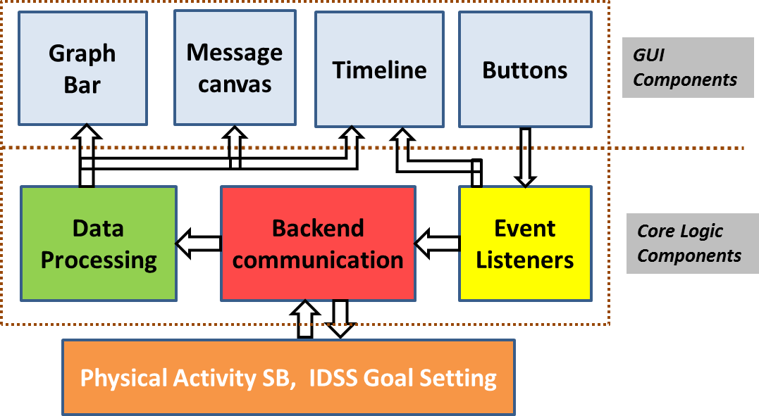

Figure 13: Application Components and interactions

Application components can be grouped into GUI and Core Logic components. In the first group are *Graph Bar, Message Canvas, Timeline, Buttons,* while in the second are *Event Listeners, Backend communication, Data Processing*.

The Event Listeners component consists of five event listeners, each one waiting for a button state to change, which indicates user interaction. Upon such event and depending on the button, a request is sent to the SBs to retrieve information. Also, an update of the timeline can be issued. After the data is retrieved from SBs, it is fed into the *Data Processing* component. At this stage the data retrieved from the SBs is reformatted in a way suitable for the GUI. More detailed information on the component’s interactions is presented by the flow chart in Figure 14.

The communication with the backend is done using Backend communication block. This block uses jQuery Ajax to perform an asynchronous HTTP request towards the services endpoints. The type of request is set to "GET". To send GET parameters to the server, a Data object is used, which converts data to a query string. It is appended to the URL for GET-requests. The type of data, which is expected from the backend, is in “JSON” format. The cache is set to false which will force requested pages not to be cached by the browser. This setting will only work correctly with HEAD and GET requests. It works by appending "_={timestamp}" to the GET parameters.

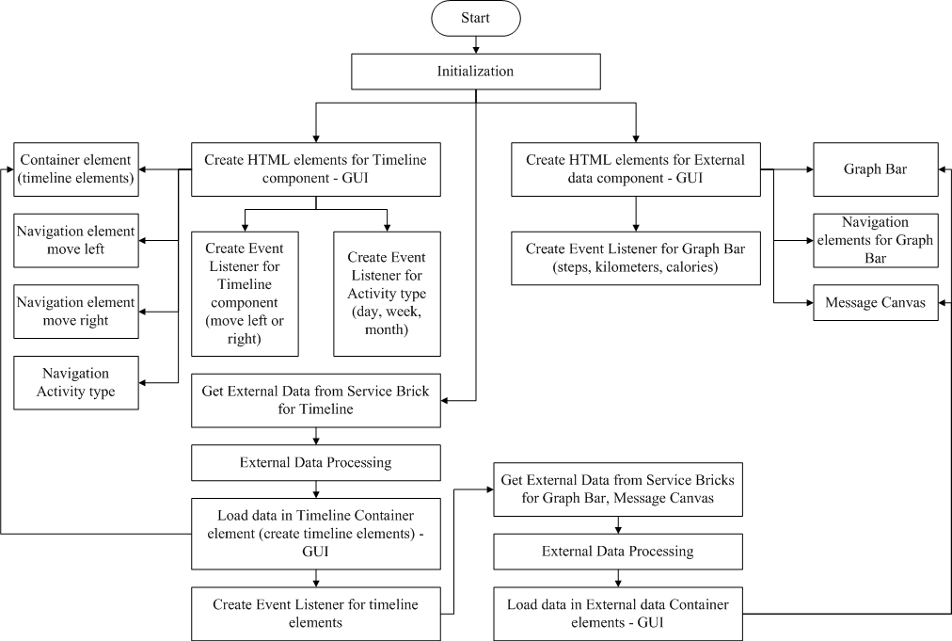

Figure 14: Detailed description of DPAM components interaction

The application is translated in the following languages: Danish, Austrian, Italian, Serbian, Macedonian, Bulgarian, Croatian and Romanian. The language is automatically selected based on the location data stored in the user profile.

### GUI Description

A snapshot of DPAM with description of its GUI components is presented on Figure 15.

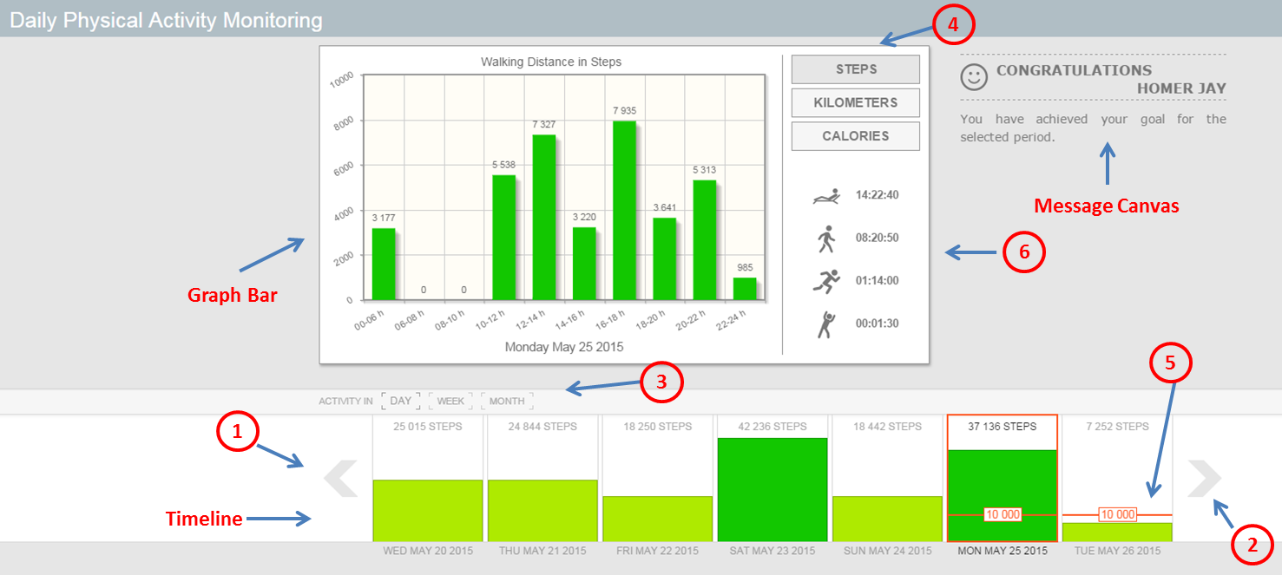

Figure 15: DPAM GUI components

The *Timeline* component is represented by rectangles, each one visually and numerically displaying the steps walked depending on the selected time period. The color changes from red to green depending on the value of the steps: the closer the steps to the goal (or above) the greener the color. Under each rectangle, the time period is displayed for which the steps were walked. The buttons with numbers 1 and 2 on the figure, represented as arrows, are used to shift the timeline to the left or right respectively. Another part of the timeline is buttons for time duration selection, marked as number 3 in the figure. There are three buttons for three durations: “*DAY”*, “*WEEK”*, “*MONTH”*. When “*DAY”* is selected, each rectangle of the timeline represents one day, i.e. the steps accumulated for that day. In the same fashion when “*WEEK”* is pressed a single rectangle represents the steps accumulated for one week time duration and “*MONTH”* for one month. Each rectangle is also an active button, and when pressed, detailed information for that time interval is displayed on the *Graph Bar.*

The *Graph Bar* is a visual component built with the *jqPlot* [56]and is used to visualize information about the selected time duration. Each sub interval is drawn as a bar displaying the value it is representing on top of it. Furthermore, the color of the bars is changing from red to green, depending on how close this value is to the daily goal. If “*DAY”* is selected the 24 hours are divided in 10 intervals – the first one between 0 and 6 o’clock and the rest from 6 to 24 o’clock divided into 2 hours intervals. If “*WEEK”* is selected, each bar represents one day and when “*MONTH”* is selected, each bar represents accumulated steps for two days. Also, at the bottom of the *Graph Bar* is represented the displayed time interval. There are three buttons associated with the *Graph Bar* marked as 4 in Figure 7. These buttons are *“STEPS”*, *“KILOMETERS”* and *“CALORIES”*. With each button a different quantity for display in the *Graph Bar* is selected. The default is in steps, which is equivalent to pressing the *“STEPS”* button. When *“KILOMETERS”* is pressed, each bar displays the distance the user covered for the selected time period in kilometers. Similarly, when *“CALORIES”* button is pressed, the bars represent the calories the user burned for the selected time period. The colors are selected to give an immediate idea of the performance: orange (values close to zero) represent unacceptable values, yellow (below the target) represents not-so-good performance and green represents a good performance.

The *Message Canvas* is a part of the application, used to display information to the user. It consists of simple message text that informs the user if the daily goal is achieved. The goal for a specific day is retrieved from the IDSS Goal Setting reasoner. It is displayed as a line, overlaying each of the time bars in the timeline. Inside this line is embedded the numerical value for the goal, allowing the user to have quantities notion of it. The other part of the application marked with 6 is the activity statistics plot, positioned just under the buttons for quantity selection. The app utilizes the activity recognition algorithm in the Physical Activity service brick to retrieve this information. There are 4 kinds of activity recognized each one represented by icon. From top to bottom they are arranged as follows: ‘Resting’, ‘Walking’, ‘Running’ and ‘Exercising’. The activity is request per specific day and additional accumulation is performed inside the Data Processing component of DPAM.

## Daily Functioning Monitoring

The maintenance of daily functioning can be valuable factor for the independent living of elderly people. The monitoring of daily functioning can help improving the quality of life of the elderly people, because immediate actions can be taken in case a deviation is detected from specific daily patterns. The Daily Functional Monitoring (DFM) application is intended to provide to the user information about their daily functioning such as cooking, bathing, sleeping, entertaining etc. It displays how much time the user spent on a specific activity or in a specific location. DFM could improve eldercare by providing a sense of safety and quality of life by detecting key events and by enabling timely intervention. Long-term monitoring can allow caregivers to make informed decisions or to assess response to a treatment.

### Functionality Description

The application retrieves data in the same fashion as DPAM does (see 3.2.1). Upon application initialization and user interaction, the request for data is send to the backend. The response data is further processed and visualized. To deliver the application functionality, the utilized backend components are listed in Table 16.

|  |  |
| --- | --- |
| *Backend Component* | *Utilization* |
| FUNCTIONING ACTIVITY,  Daily Functioning SB | *The application connects to this endpoint of Daily Functioning Service Brick to extract information about the different daily activities performed by the user and also their time of performance* |
| Mood Lifestyle Reasoner | *The application utilizes the information from this reasoner to display into simple motivational messages in the message box* |

Table 2: List of backend components utilized by DFM application

The Daily Functioning service brick implements intelligent algorithms which, based on sensor data estimate the user activity at any time. These activities are further requested by the application and each activity is displayed using icons and texts. Additionally the application requests user mood for one day ago, and based on the status a simple motivational message is displayed. The Mood LR is another intelligent component that utilized by the DFM app and its decisions are displayed.

The application consists of the following sub components:

* *Timeline;*
* *Timeline buttons;*
* *Storyline;*
* *Storyline boxes;*
* *Simple message box;*
* *SB communication block;*
* *Data processing;*
* *Event listeners.*

A diagram of the interaction between the components is presented in Figure 16.

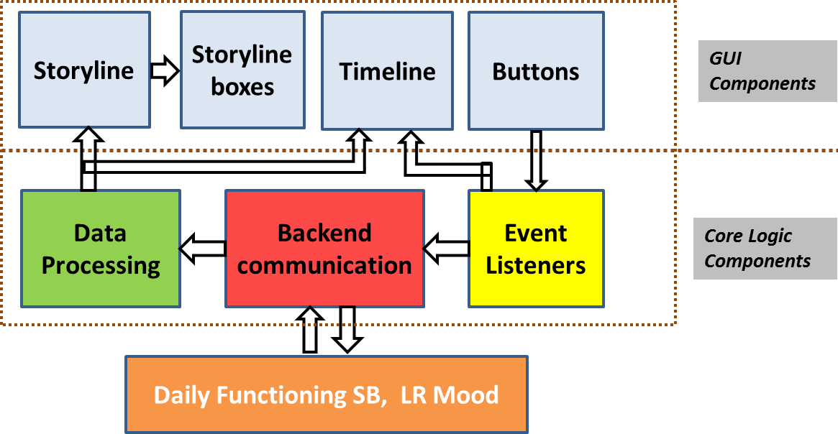

Figure 16: DFM Application Components and interactions

The application’s components can be grouped into GUI and Core Logic components groups. In the first group are *Timeline, Timeline Buttons, Storyline, Storyline Boxes* and *Simple message box* while in the second are *Event Listeners, SB communication* and *Data Processing*. The Event Listeners component is comprised of four event listeners each one waiting for a button’s state to change, which indicates user interaction. Upon such event and depending on the button, a request is sent to the SBs to retrieve information. Also, an update of the timeline can be issued. After the data is retrieved from SBs, it is fed into the Data Processing component. At this stage the data retrieved from the SBs is reformatted in a way suitable for the GUI. More detailed information of the components interactions in an algorithmic flow manner is presented in Figure 17.

The *SB communication* block uses jQuery Ajax to perform an asynchronous HTTP request to the SBs. The type of request is set to "GET" and is sent using SB ULR address. To send GET parameters to the server Data object is used, which converts data to a query string. It is appended to the ULR for GET-requests. The returned data from SB is expected to be in “JSON” format. The cache flag of Ajax is set to false, which forces requested pages not to be cached by the browser. This setting will only work correctly with HEAD and GET requests. It works by appending "_={timestamp}" to the GET parameters.

The application is translated in the following languages: Danish, Austrian, Italian, Serbian, Macedonian, Bulgarian, Croatian and Romanian. The language is automatically selected based on the location data stored in the user profile.

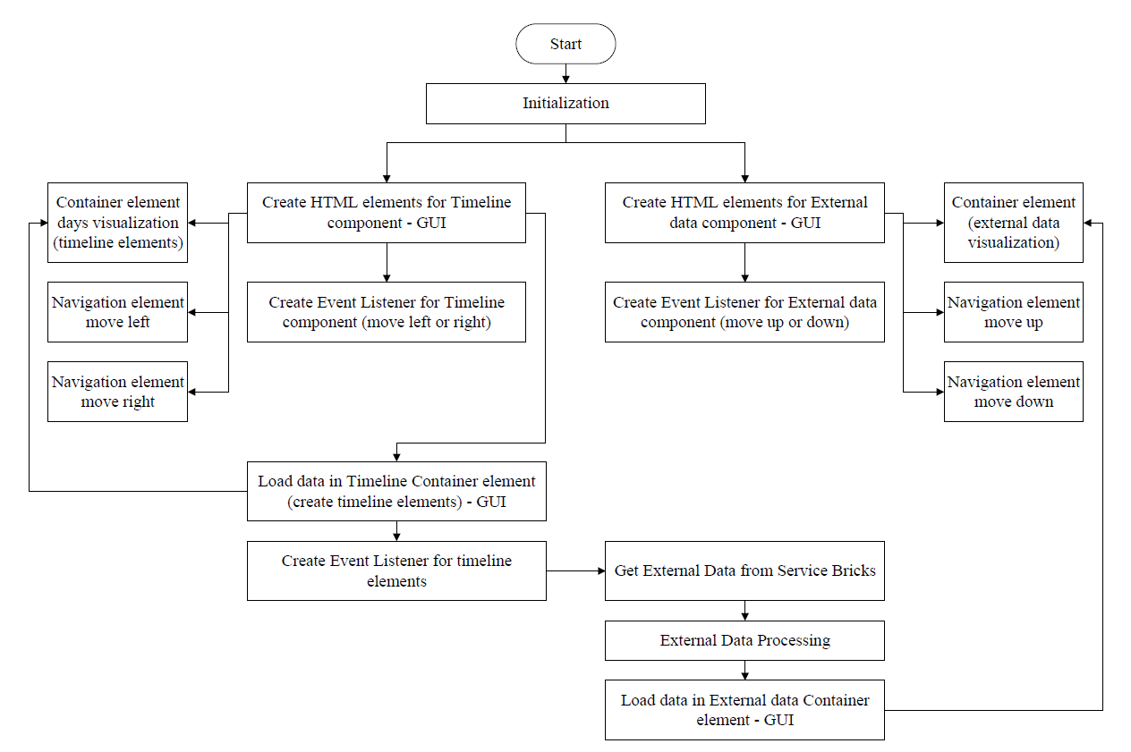

Figure 17: Detailed description of DFM components interaction

### GUI Description

A snapshot of DFM application with numeration different GUI components is presented inFigure 18.

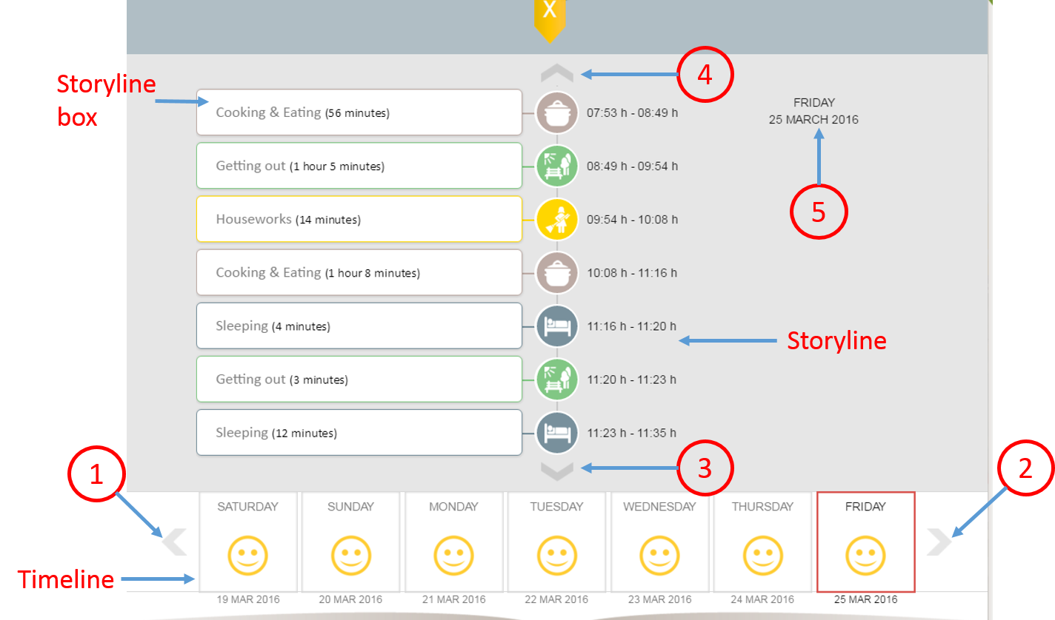

Figure 18: The Daily Functioning Monitor – Timeline snapshot

The *Timeline* component is represented by 7 rectangles, each one visually displaying the time period (Day of Week, Month, Date and Year). The selected Day is outlined. The buttons pointed with 1 and 2 on the figure, represented as arrows, are used to shift the timeline to the left or right respectively. Each rectangle is also an active button, meaning that when pressed, detailed information for that day is displayed on the *Storyline.*

The *Storyline* is the vertical line that represents events, observed for the period of one hour. The buttons with numbers 3 and 4 on the figure, represented as arrows, are used to shift the storyline up or down respectively (to the previous or the next period).

The message box, marked with 5, is another component used to deliver to the user the intelligent decision made by the LR Mood. The messaging is in initial state and only simple messages are displayed. More comprehensive messaging including mood improvement recommendations are planned for future development.

The *Storyline box* relates to a specific event of the observed period. Each type of box has the following items and are indicated by arrows on Figure 19:

* Event’s name;
* Event’s description;
* Cartoon;
* Duration;
* Icon;
* Date;
* Time.

Based on the event name, there are four types of event-boxes: Cooking&Eating, Sleeping, Taking shower, Resting&Entertaning and Outdoor activity.

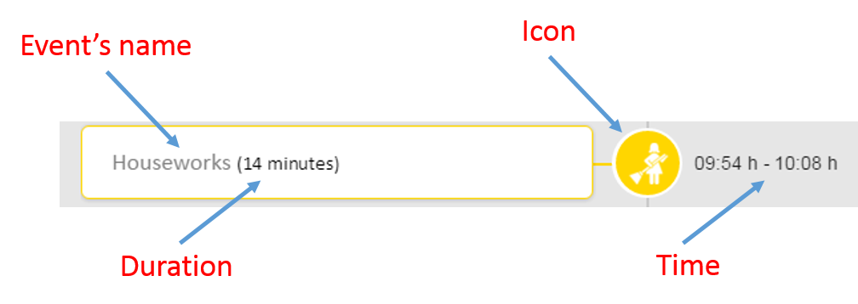

Figure 19: Storyline box elements description

## My Sleep Application

The ‘My Sleep’ application has the purpose of presenting quantitative and qualitative interpretation of the user’s sleep behaviour based on the home sensing. This version of the application, shows an interpretation of last night sleep data.

### Background

The added-value of the *My Sleep Application* for the general elderly population is to support self-awareness about each individual sleeping patterns and create alerts whenever the sleeping behavior deviates from expected. Furthermore, My Sleep Application can support the users improving their quality of sleep by instructing into what is known as sleep hygiene, i.e. a set of good practiced regarding behavior in the bedroom and in the hours leading up to sleep [21].

Elderly with chronic diseases commonly experience higher rates rates of sleep problems than those without [58]. The quality of sleep of COPD patients is considerably impaired [22], with more than 50% of the patients reporting sleep-related complaints [22]. Elderly suffering from COPD might also indicate specific sleep disturbances with the total sleep time is considerably lower [23]. This can be explained by the fact that people with COPD are more times awake during the night, which lead to a reduce in sleep efficiency [24].

The biggest value of the *My Sleep Application* to COPD patients is to inform about sleep hygiene and coach the users into a healthy sleeping behavior.

### Functionality Description

The application consumes service brick data describing sleep events such as: tome the user went to sleep, time the user woke up, the duration of sleep, the sleep efficiency, etc. This data is processed and semantically represented within the interface. Complementary, the sleep lifestyle reasoner is requested to provide patterns of sleep behaviour for the user and the information is displayed according to each sleep period described in the interface. These connections are depicted inFigure 20.The sleep sensor data comes from the Fitbit charge sensor [25].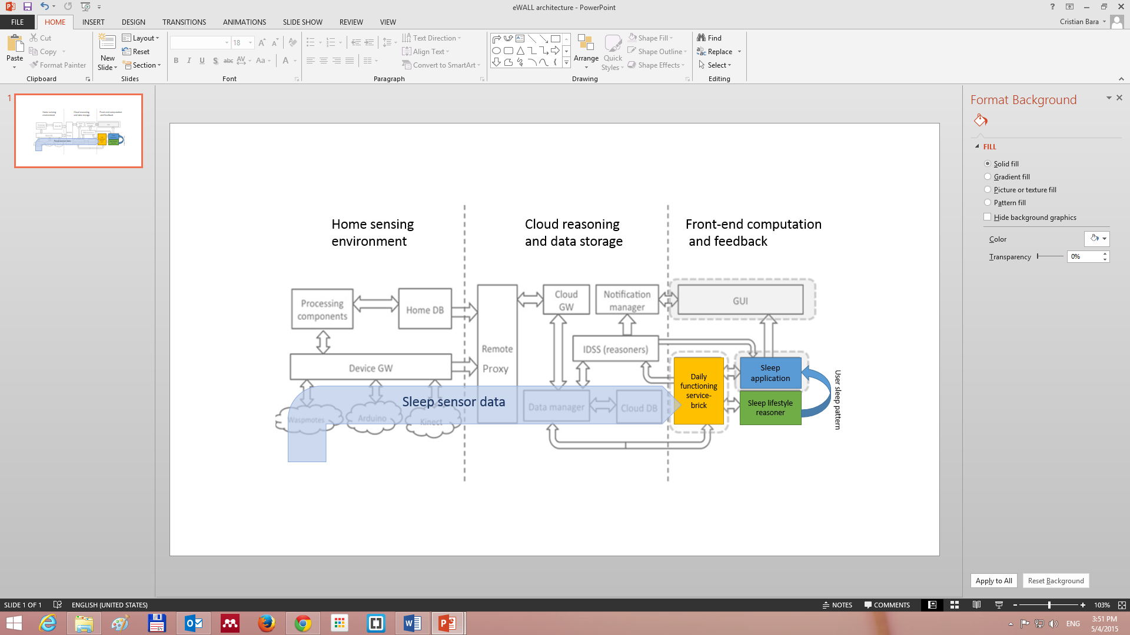

Figure 20: Illustrates Connection between the sleep application and the dependent eWALL components

Thus we present our user’s last night behaviour in the context of her/his routine behaviour.

Additionally, the application computes quality of sleep parameters, taking into account objective parameters according to medical norms in measuring quality of sleep. The sleep data can be visualised for one day at the time, or one week at the time.

### GUI Description

Based on usability tests performed in all four test sites, several redesign outcomes have been implemented.We will point out the most important changes. Figure 21 (a) depicts the new interface for the sleep application.

The sleep application user interface was adapted to the recommendations which came out of the small-scale evaluations. As with all the monitoring applications, this one also implements the metaphor of eWALL automatically writing the users book of sleep (cf. Figure 21).

The previous prototype implementing the timeline, proved to be inefficient in delivering a good user experience. Most participants pointed out that the sleep period and sleep interruption information is highly repetitive and unnecessarily complex. Therefore in the new design this information was reduced to two sentences.The language of this application is colloquial, which proved to be much easier to understand than the previous way of formulating the information.

On Figure 21(a) and (b) is illustrated the summary of one night sleep expressed in 4 paragraphs. This implementation reduces considerably of the information overload of the interface.

1. 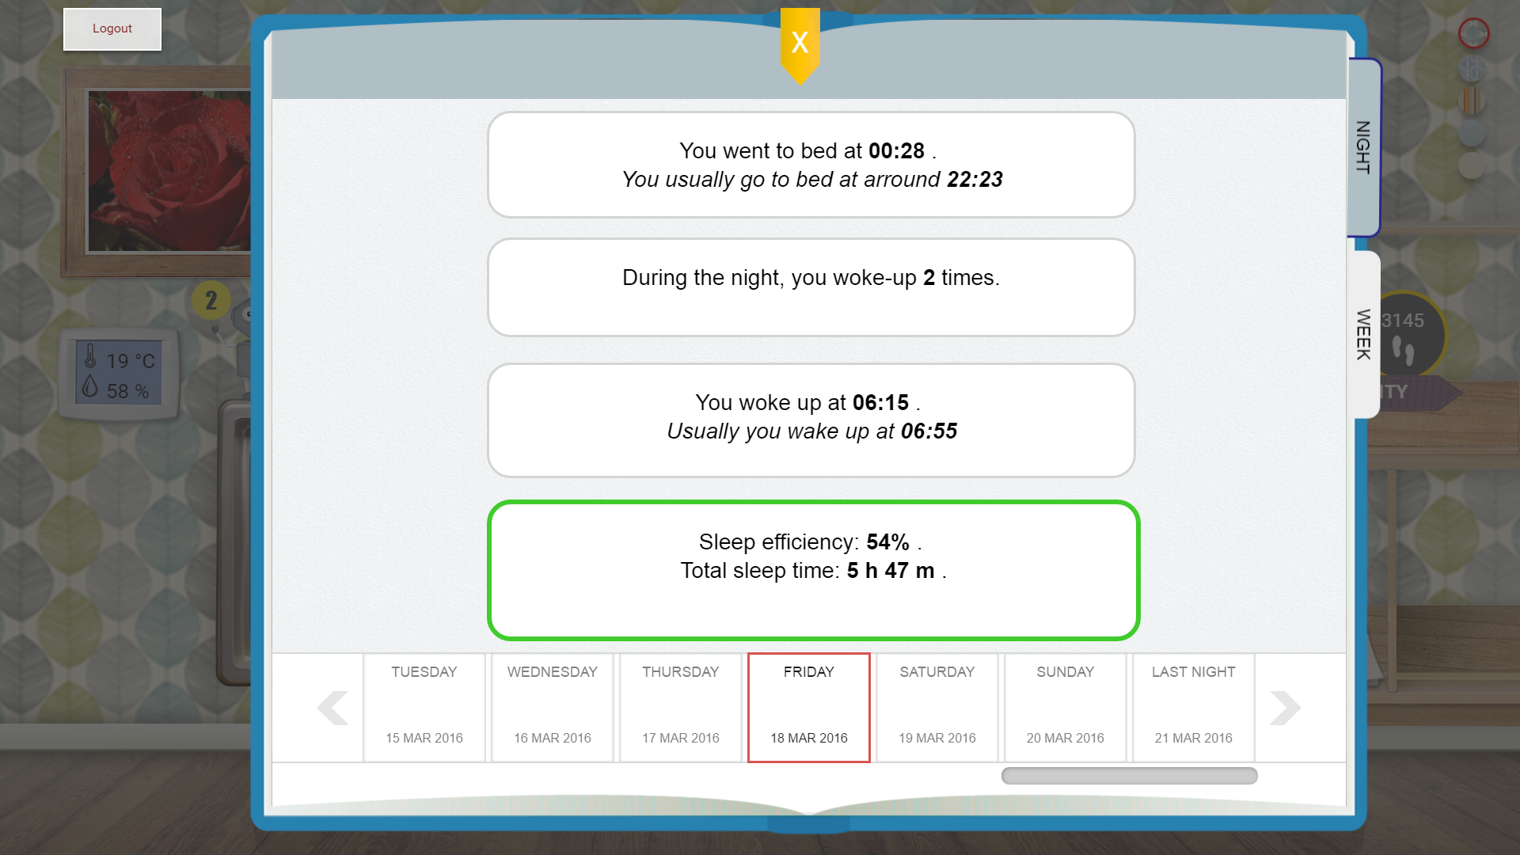
2. 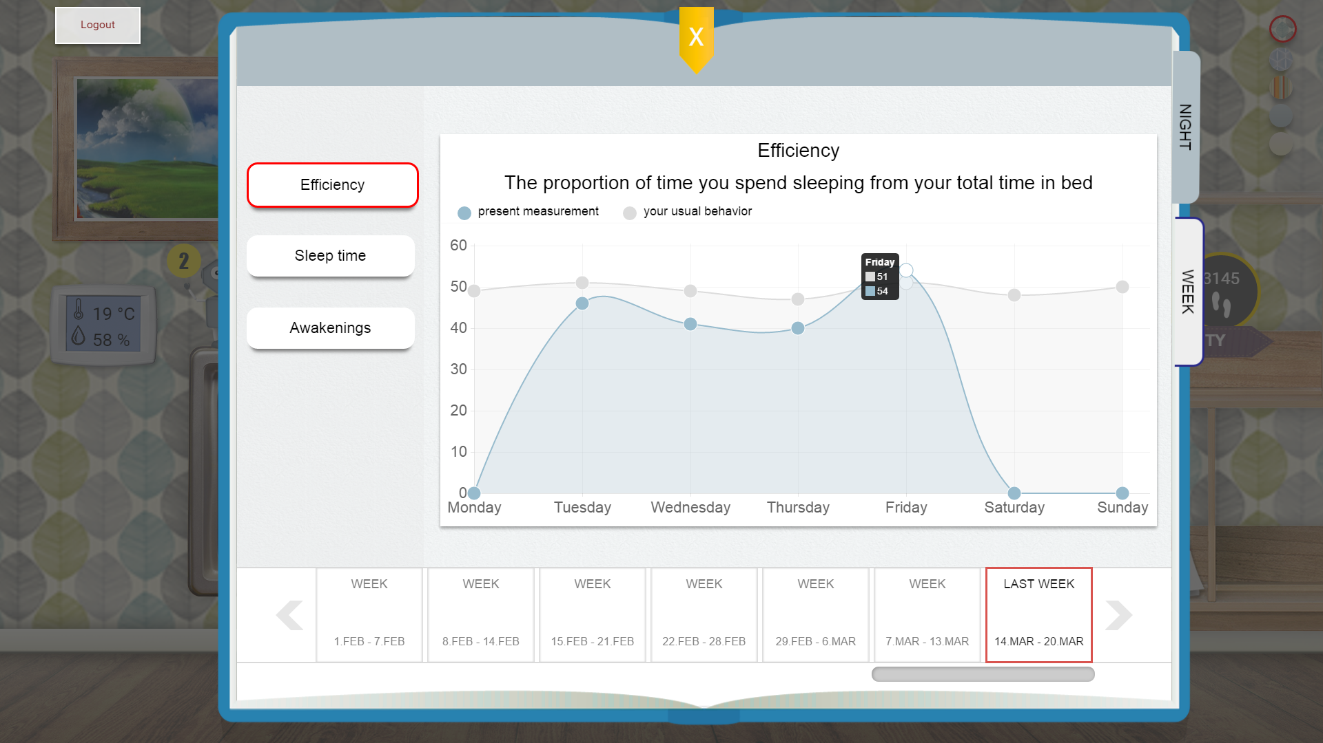

Figure 21: The eWALL Sleep application redesigned interface, based on elderly user and expert user tests. (a) Depicts the daily sleep review. (b) Depicts weekly sleep efficiency view.

Test outcomes show the need of showing a weekly overview, similar to all other monitoring applications (in this case, books).

The Figure 22 and Figure 23 illustrate the three variables for which the application of his weekly overviews.

Sleep efficiency (cf. Figure 22), counts the proportion of time do you spend in bed with the intention of sleeping and the actual time spent sleeping. This measurement is expressed in percent.

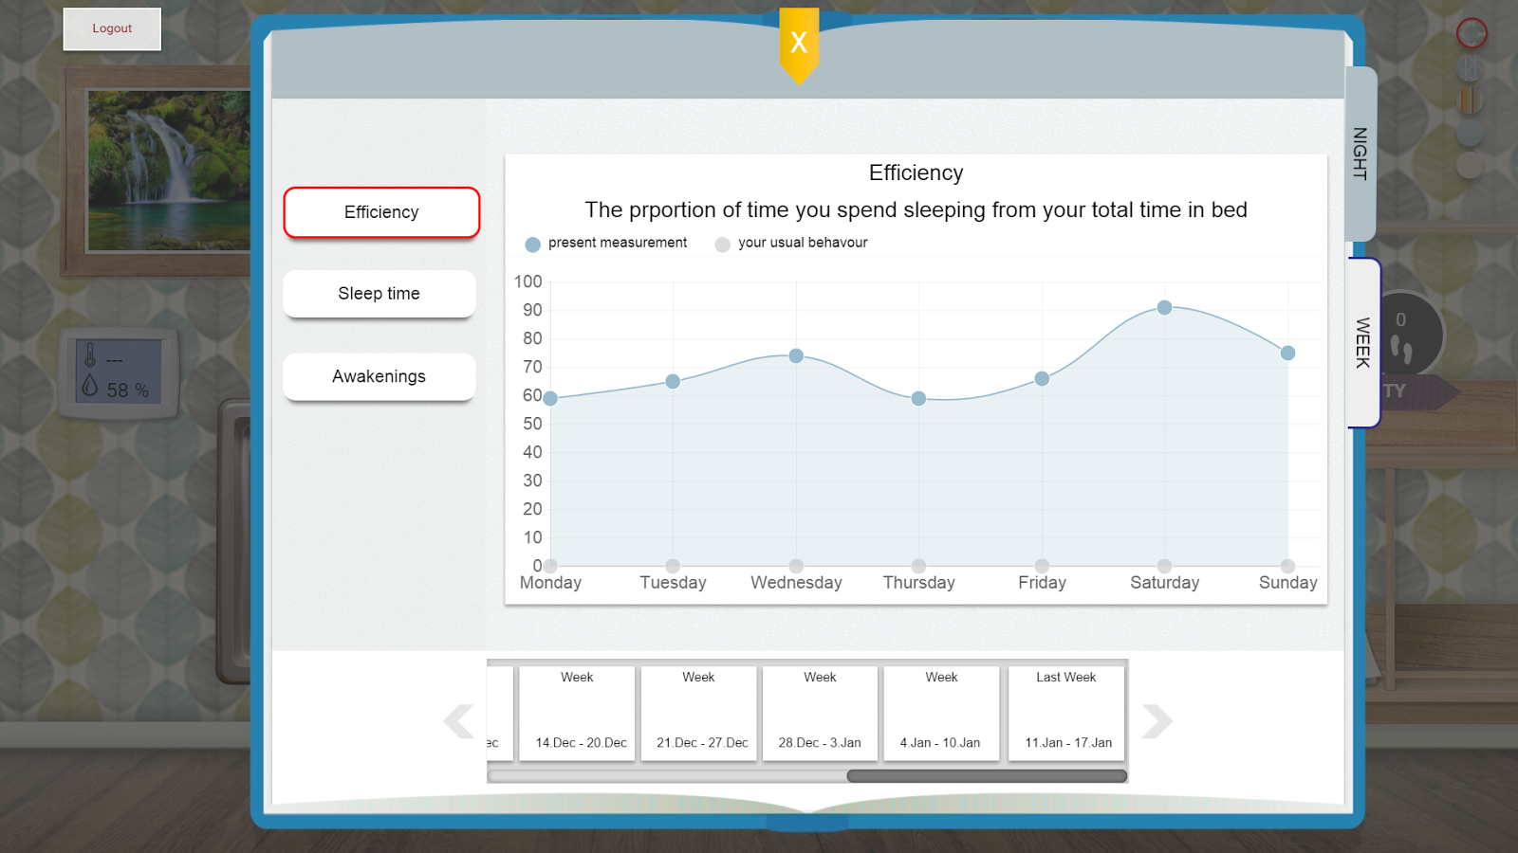

Figure 22: The eWALL Sleep application redesigned interface, depicting the sleep efficiency panel

Sleep time counts the total time in minutes the user has been sleeping. The Figure 23 shows the weekly overview if this measurement.

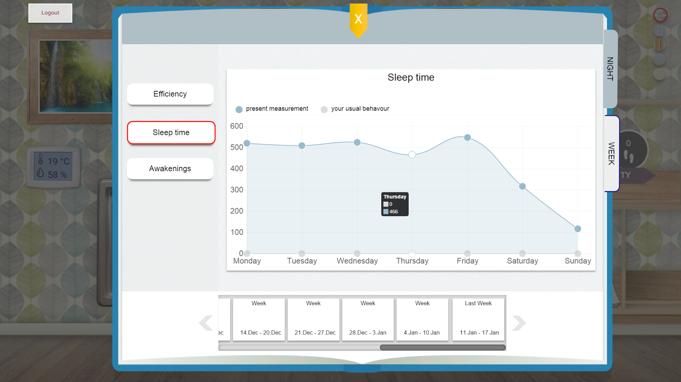

Figure 23: The eWALL Sleep application redesigned interface, depicting the sleep time panel

The number of awakenings during the sleep period is also important. The Figure 24 shows the weekly overview of this measurement.

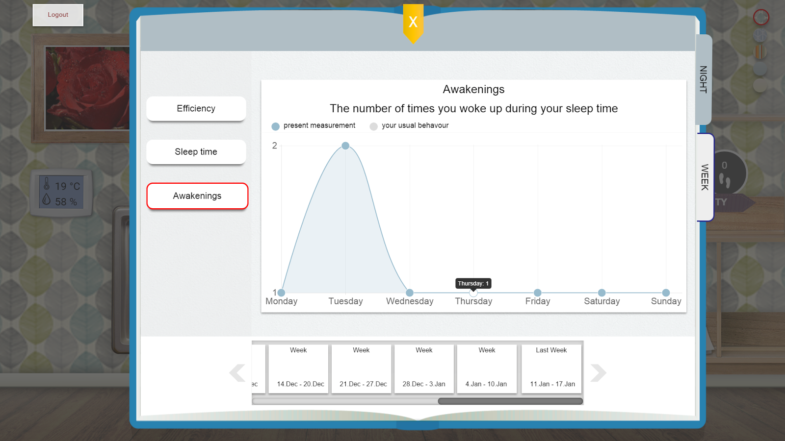

Figure 24: The eWALL Sleep application redesigned interface, depicting the awakening panel

The outcomes from the service brick and the lifestyle reasoner output interpretation are represented through clear text in the daily view and colour coded in the weekly view (blue for current - service brick - measurements and grey for average - lifestyle reasoner - measurements). The text is short and concise, eliminating the perception of “long boring read” as reported in the first prototype evaluation.

## Healthcare monitor

“My Health” application is a key component of the eWALL system and it brings major value for the COPD and ARI patients. It supports taking vital signs measurements (pulse, oxygen saturation in blood and blood pressure) by the primary users with the medical devices that are compliable with the eWALL platform. Knowing the health measurements will help both the eWALL primary users and caregivers to understand how the primary users’ health is progressing.

### Functional Description

My Health application is fed up with vital signs data coming from measurements that the eWALL primary users are expected take on their own.In current stage, eWALL is compliant with the Omron blood pressure monitor and the Nonin Pulse-oximeter which the primary user uses to take measurements of his/her heart rate, oxygen saturation in blood (SPO2) levels and blood pressure.

### GUI Description

The GUI of My Health application supports the users to measure, store and visualize their personal vital signs data through several interactive windows. Based on a sequence of usability tests from expert and potential eWALL users, a number of changes and graphical improvements has been made to make the graphical interface consistent with the rest of the applications and well accepted by the users. The refinements were performed in cross-work package collaboration between medical and technical partners in the project.

When the application is launched the main window of My Health appears in a book frame as shown on Figure 25. The user may either start with taking a new measurement or observe the already existing ones. If no measurements have been taken today, the table will be empty. Each measurement is labeled with color to help for better understanding.

In order to take the measurement the user needs to possess the compliant with eWALL medical devices. To get more information on how to take the measurement the user can choose between HEART RATE, SPO2 and BLOOD PRESSURE, as shown in Figure 25-(1), and then follow the instructions that appear on the screen. The vital signs measuring instructions stand to support the independent taking of measurements by the primary user, an example is given in Figure 26. If any vital signs measurement has been made the respective data is visualized given on Figure 25-(3).

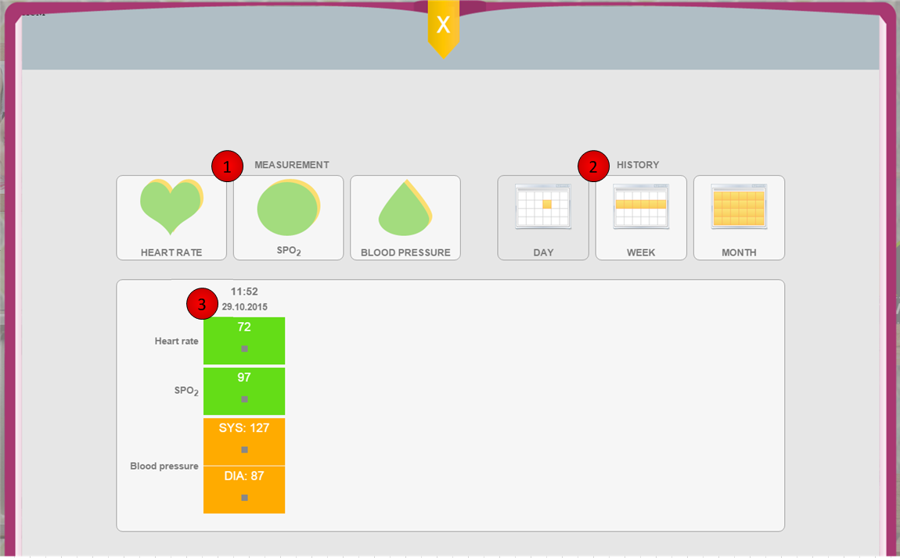

Figure 25: My Health application main window: 1-taking a measurement; 2-history overview; 3-today's measurements

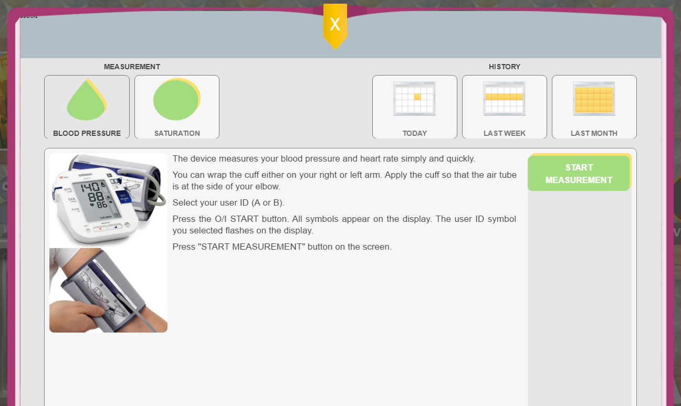

Figure 26: Taking a blood pressure measurement instructions in My Health application

When choosing the history preview (Figure 25-(2)), the user has access to the history of previous measurements for the DAY, WEEK and MONTH.

“This Week” button, is for getting a list of this week’s measurements. “No measurements” and “future days” will not have any information, so the user will see gray empty places in the table.

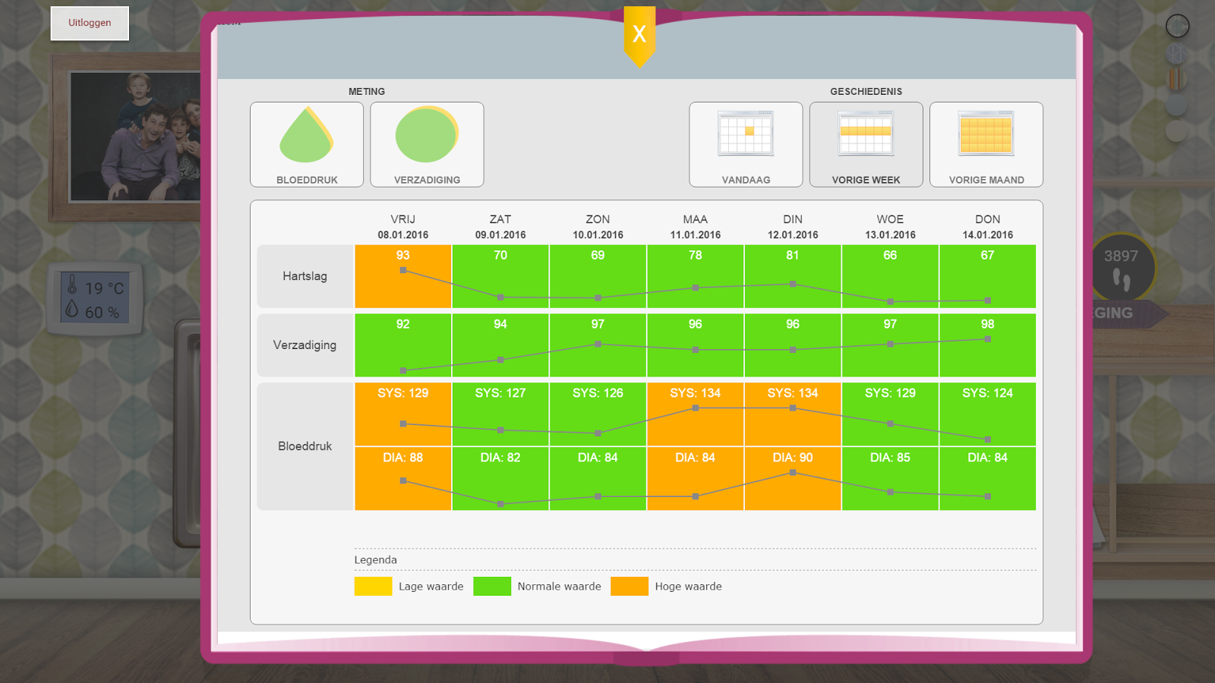

Figure 27: A week vital signs measurements history overview

“This Month” is for getting a list of the month's measurements. Empty parts of the table means the measurements were not taken at the respective time frame.

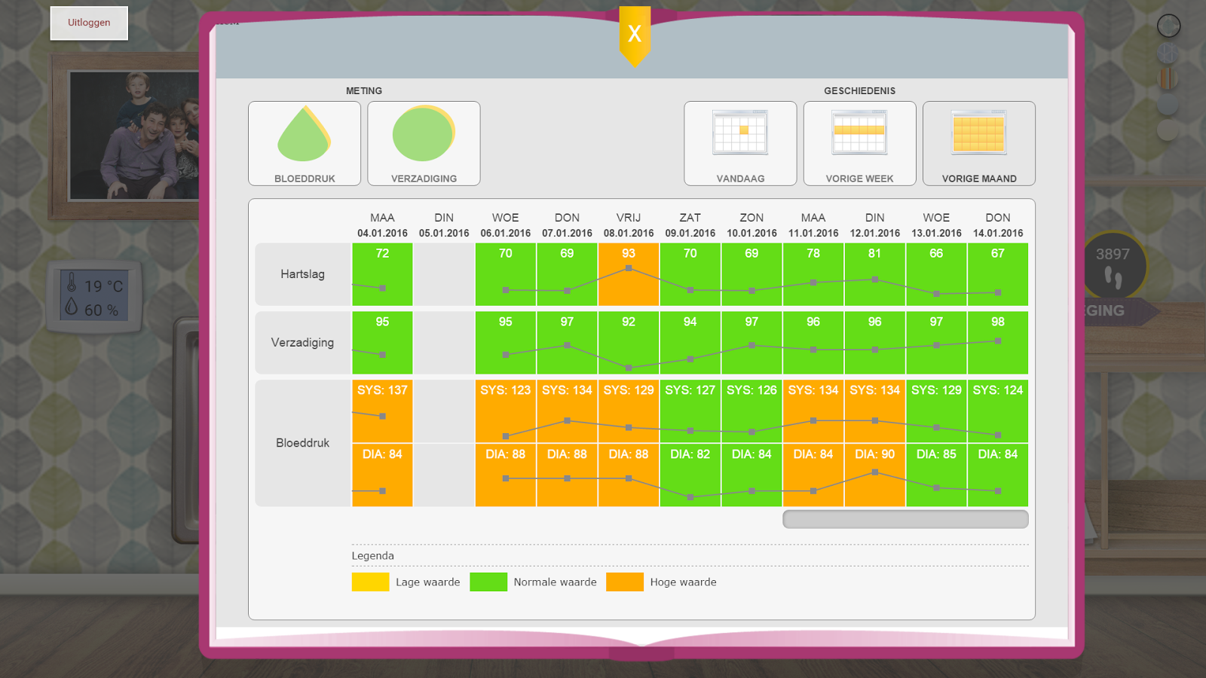

Figure 28: A week vital signs measurements history overview

## Physical Trainer

This application aims to keep the eWALL primary users physically fit by offering personalized video exercise routines which the user should follow. This version of the video exercise trainer does not require wearing any sensors, in order to perform the exercise, but the user is being suggested to make sure she is wearing her activity sensor, in order to monitor the activity of the user.

### Background

Preserving the ability to perform functional movements, such as walking or climbing a set of chairs, is very important to perform daily activities independently, such as households or grocery shopping. Such functional movements are conditioned by four types of physical performance: endurance, strength, balance and flexibility. Endurance concerns the ability to, for example, walk 400 meters without the need to stop and it is trained by keeping an active lifestyle. Within eWall, endurance is trained with My Activity Application. Strength, balance and flexibility are trained within the Physical Trainer Application.

The Physical Trainer Application aims to keep the eWALL primary users physically fit by offering personalized video exercise routines. It comprises a dataset of 60 video recordings of different exercises which are guided and recorded by a gero-physiotherapist. The set of videos is based on the Otago Exercise Programme (OEP), a validated program designed for older adults to prevent falls by training specifically strength and flexibility. For a systematic review on the impact of the OEP in fall prevention please refer to [26].

Each training session lasts about 30 minutes, consisting of (1) a 5-minute warming-up, (2) a main phase of exercises, and (3) a 5-minute cooling down. The user rates his/her enjoyment and perceived difficulty related of an exercise after each exercise of the main phase. The selection of exercises for each training session is based on previous ratings of the user.

#### Added value for ARI

Physical exercise interventions have shown being beneficial for older adults in supporting activities of daily living and delaying functional decline. For reviews on the results of such interventions please refer to [27]. The added value of the Physical Trainer Application for the general older population is to provide training of strength, balance and flexibility in order to support independence on activities of daily living and prevent falls. This value is clearly shared with the MCI and COPD elder patients.

#### Added value for MCI

The literature suggests that physical activity reduces the risk of dementia in mild cognitive impairment patients [28]. Therefore, it is of utmost importance to this target group to achieve or maintain an active lifestyle despite of their disease. When the cognitive impairment worsens, patients might start fearing to leave their homes, leading to a decrease of physical activity. A home-based physical activity intervention, as the Physical Activity Trainer, is likely to support these patients keeping their balance, strength and flexibility and therefore avoiding muscle atrophy. Previous studies suggested that people with memory complaints, inclusive MCI, can successfully participate in home based programs to promote physical activity [29].

#### Added value for COPD

Physical activity levels of COPD patients are considerably lower than those of healthy individuals [30]. Moreover, as the condition worsens, patients tend to become less active, what makes them fear to exercise, worsens the disease and enters in a vicious cycle [31]. One barrier to perform physical activity frequently mentioned by COPD patients is the fear of dyspnea [32]. Within eWall, COPD patients are encouraged to wear the oxygen saturation sensor while performing the exercises. An alert message is provided encouraging taking a break whenever their oxygen saturation level goes below the recommended safe threshold. The Physical Activity Trainer supports COPD patients being physically active within the safety of their home environment. Similar home-based interventions have proven being effective in the past [33].

### Functional description

An IDSS reasoner, named PARS recommender, will suggest new exercise routines based on the ratings, the user provided during the previous video exercise sessions (cf. Figure 29). Every routine is composed of 5 warm-up exercises, a number of core exercises according to the reasoner output and 5 cooling-down exercises. Only the core exercises are available for rating. The user can rate each core exercises according to how much she likes performing the exercise and how difficult was to perform the exercise.

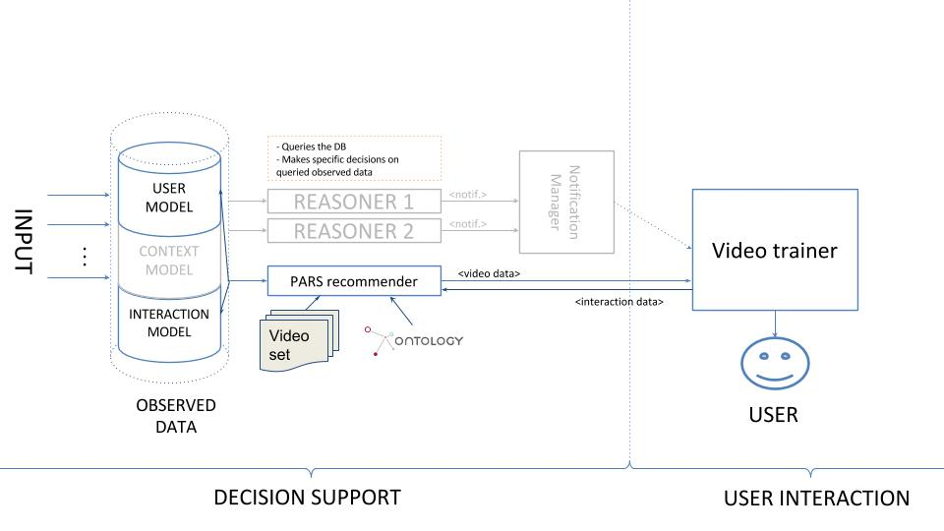

Figure 29: The eWALL PARS recommender

The PARS recommender maps the user model and interaction model to its ontology, in order to establish its user baseline. Based on this information, the recommender builds the first exercise routine. Following the routine, the user is asked to rate the core exercises. The ratings are sent to the recommender, where the interaction data is mapped to the ontology model and the recommender updates its knowledge about the user physical fitness profile, for next recommendations.

A new routine will be built based on the following reasoning:

* The user must be able to perform the complete new routine.
* The routine should display the videos which the user likes more.
* The routine must be challenging enough for the user (based on previous difficulty ratings)

### GUI description

The video exercise trainer user interface was adapted to the smart living room metaphor. When launched, the TV from the living room comes in the first plain and displays the start page (cf. Figure 30). This page contains basic instructions which help prepare the user for the upcoming session. Some exercises require extra equipment. The user is informed about this in the start page.

During the time, the video training application is on screen, the proxemics interaction behavior (screen switching to passive when the user is further then 1.5 meters from the screen) is canceled, allowing the user to perform these exercises at a higher distance from the screen.

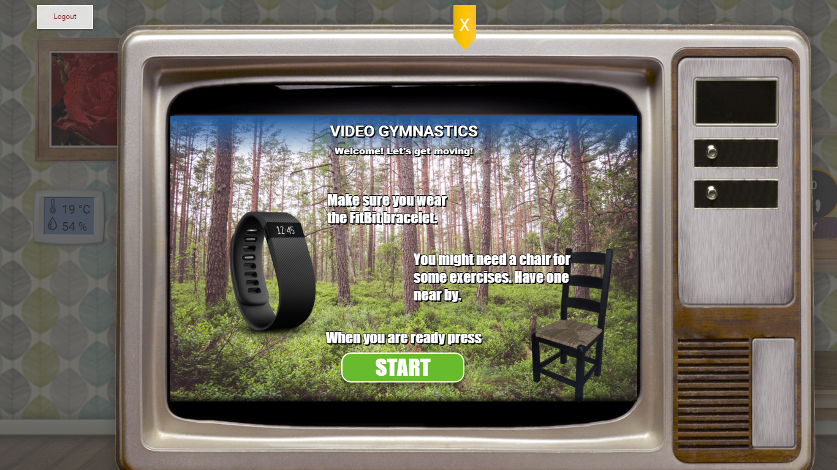

Figure 30: The first screen of the physical trainer application showing preparation instructions and the START

When the user is ready to start her routine, she touches the green start button. This will result in the application showing the first warmup exercises video, as depicted in the Figure 31.

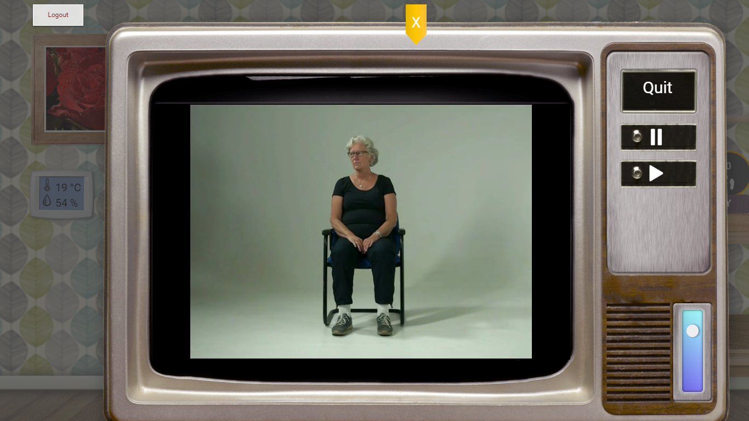

Figure 31: An instance from the first warmup exercise. In this screen, the personal trainer application displays the video on the television screen, a quit button, a play button, a pause button and a volume slider

Each warm-up exercise has just a short resting period of 5 seconds. This resting period is deliberately chosen to be short in order to prepare the participant for a more demanding effort.

During a video playout (regardless whether warm-up, core, or cooling down) the user can pause or play the video. Also, when the user chooses, she can quit the routine by pressing the button from the top right side of the screen. This action will bring the user to the start page.

A sound volume control can be found on the bottom right side of the screen.

The volume of the video can be set by sliding up (for higher volume), or down (for lower volume)

Below, we depict a core exercise (cf. Figure 32), which demands much more effort from the user. After each core exercise there is a rest time (cf. Figure 33). During this time, the user will be asked to rate the performed exercise by answering the following questions:

* *How much did you enjoy this exercise?*

For answering this question, the user can choose to select a number of stars (minimum none, maximum 5).

More stars means the user enjoyed the exercise.

* *How difficult was this exercise?*

For answering this question, the must choose a number of stones from the buttons below the question (minimum none, maximum 5).

More stones mean the user found the exercise more difficult to perform.

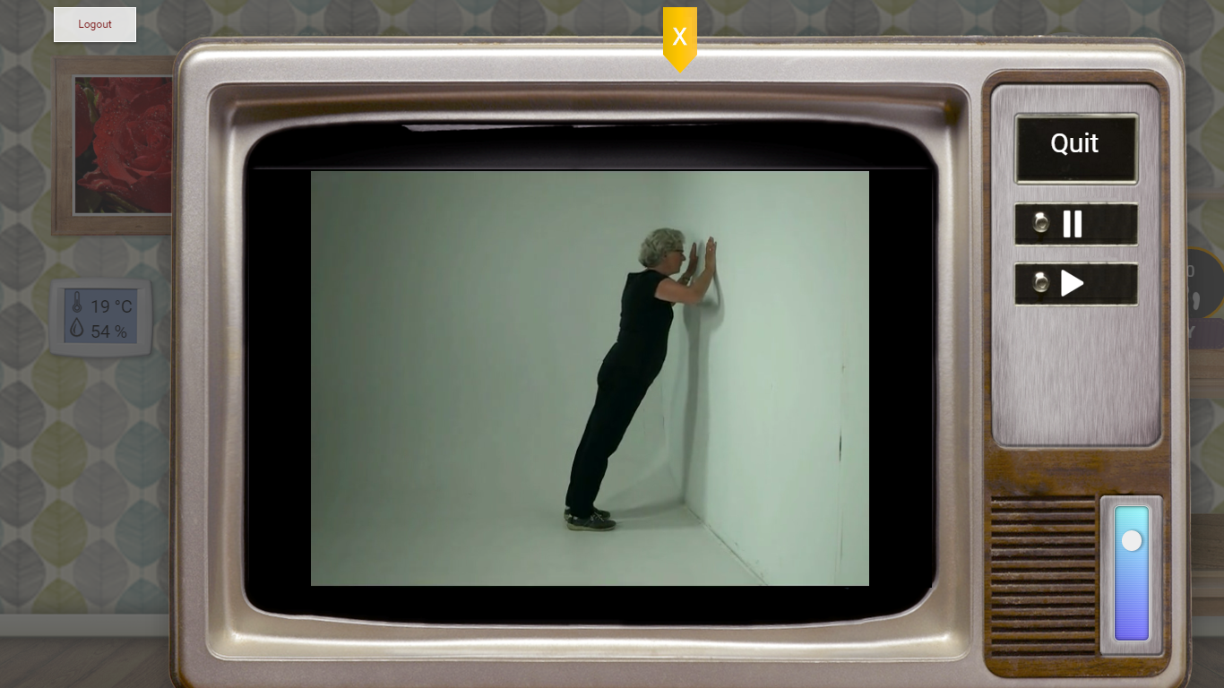

Figure 32: An instance from a core exercise

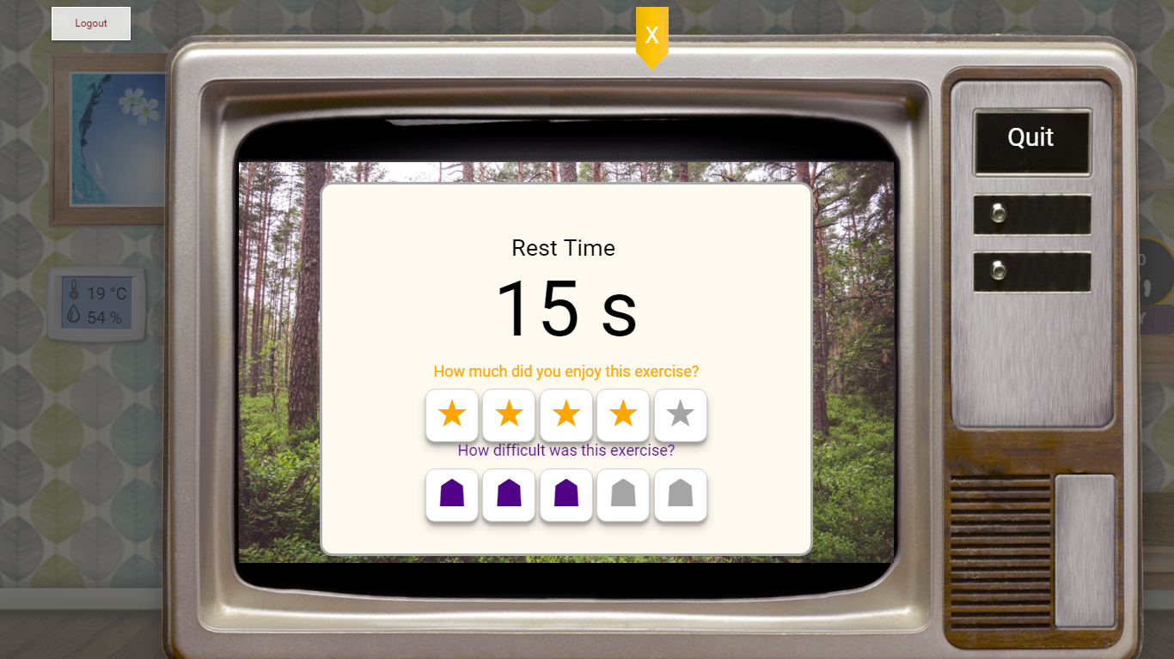

Figure 33: An instance of the rating screen of the core exercise

The core exercises are followed by the cooling down videos. These videos prepare the user’s body for rest. For each routine it is recommended that the user performs both warm-up and cooling-down exercises, in order to avoid muscle pain and injury (cf. Figure 34).

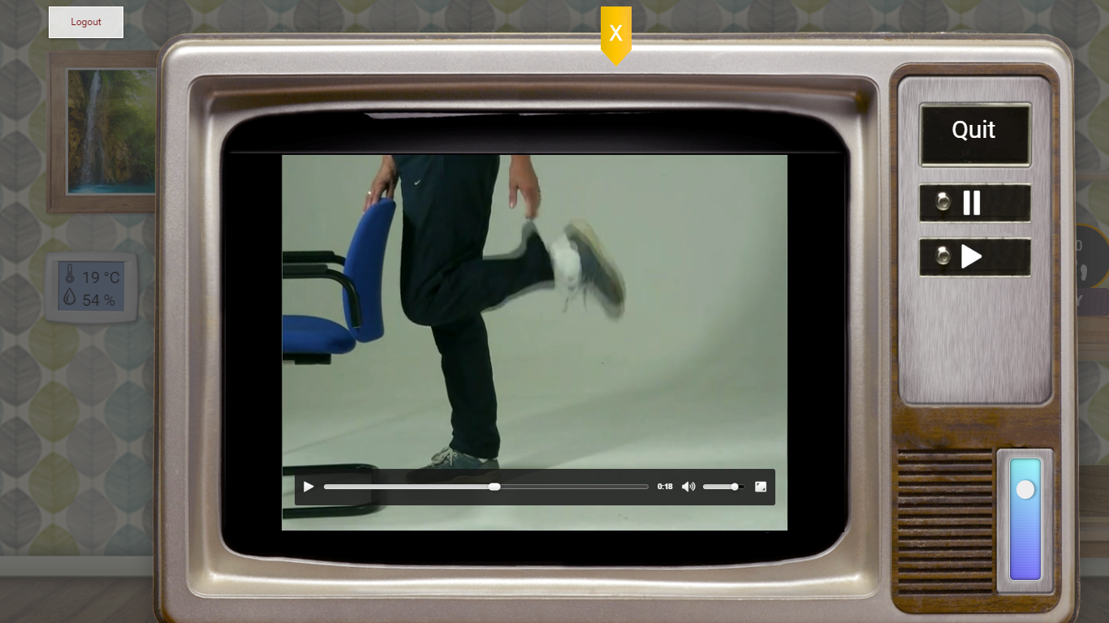

Figure 34: An instance of the cooling-down exercise

# Bibliography

|  |  |
| --- | --- |
| [1] | R. Fielding, "Chapter 5 of Roy Fielding's dissertation," [Online]. Available: http://www.ics.uci.edu/~fielding/pubs/dissertation/rest_arch_style.htm. [Accessed 24 10 2014]. |
| [2] | "eWALL Deliverable D4.3.2, Cloud middleware services for eWALL,," October 2014. |
| [3] | *Integral of the Modulus of the Accelerometer output.* |
| [4] | "eWALL Deliverable D4.2.2, Intelligent support system for eWALL," October 2014. |
| [5] | "eWALL Deliverable D5.2.2, Lifestyle reasoning: Fusion for activities, situations and their patterns," October 2014. |
| [6] | "eWALLDeliverable D2.7, Final user and system requirements and architecture," February 2015. |
| [7] | "HTML5," [Online]. Available: http://www.w3.org/TR/html5/. |
| [8] | "JavaScript," [Online]. Available: http://www.w3.org/standards/techs/js#w3c_all. |
| [9] | "CSS," [Online]. Available: http://www.w3.org/Style/CSS/. |
| [10] | "Angular JS," [Online]. Available: ttps://angularjs.org/. |
| [11] | "HTML4," [Online]. Available: http://www.w3.org/TR/html401/. |
| [12] | "Document Object Model," [Online]. Available: http://en.wikipedia.org/wiki/Document_Object_Model. |
| [13] | "AJAX," [Online]. Available: http://www.adaptivepath.com/ideas/ajax-new-approach-web-applications/. |
| [14] | "XML," [Online]. Available: http://www.w3.org/TR/REC-xml/. |
| [15] | "JQuery," [Online]. Available: http://jquery.com/. |
| [16] | "Tomcat," [Online]. Available: http://tomcat.apache.org/download-70.cgi. |
| [17] | "Ubuntu," [Online]. Available: http://releases.ubuntu.com/14.04/. |
| [18] | "Apache," [Online]. Available: http://www.apache.org/. |
| [19] | "eWALL eWALL Deliverable D2.7, Final user and system requirements and architecture," February 2015. |
| [20] | "eWALL Deliverable D4.4.2, eWALL Platform," April 2015. |
| [21] | E. J. &. W. J. K. Stepanski, "Use of sleep hygiene in the treatment of insomnia," *Sleep Medicine Reviews,* vol. 7, no. 3, pp. 215-225, 2003. |
| [22] | A. H. J. M. J. M. B. F. C. M. &. R. S. Agusti, "Night-time symptoms: A forgotten dimension of COPD," *European Respiratory Review,* vol. 20, pp. 183-194, 2011. |
| [23] | A. L. P. L. H. M. I. &. B. O. C. Valipour, " Sleep profile and symptoms of sleep disorders in patients with stable mild to moderate chronic obstructive pulmonary disease.," *Sleep Medicine,* vol. 12, no. 4, pp. 367-372, 2011. |
| [24] | M. D. R. &. Q. S. Klink, "The Relation of Sleep Complaints to Respiratory Symptoms in a General Population," *Chest,* vol. 105, no. 1, pp. 151-154, 1994. |
| [25] | "Gartner IT Glossary," [Online]. Available: http://www.gartner.com/it-glossary/context-aware-computing-2. |
| [26] | S. M. S. &. H. J. Thomas, " Does the “Otago exercise programme” reduce mortality and falls in older adults?: A systematic review and meta-analysis.," *Age and Ageing,* vol. 39, no. 6, pp. 681-687, 2010. |
| [27] | H. Z. A. B. S. K. S. M. &. Z. W. Geraedts, " Effects of remote feedback in home-based physical activity interventions for older adults: a systematic review.," *Patient Education and Counseling,* vol. 91, no. 1, pp. 14-24, 2013. |
| [28] | L. D. F. L. L. F.-S. K. G. P. S. W. C. W. M. A. …. C. S. Baker, " Effects of aerobic exercise on mild cognitive impairment: a controlled trial.," *Archives of Neurology,* vol. 67, no. 1, pp. 71-79, 2010. |
| [29] | K. L. F. L. A. O. P. X. J. G. K. R. H. J. …. L. N. T. Cox, "The FABS trial: a randomised control trial of the effects of a 6-month physical activity intervention on adherence and long-term physical," vol. 57, no. 6, pp. 824-830, 2013. |
| [30] | S. N. W. K. H. S. M. T. T. &. L. J.-W. J. Vorrink, " Level of daily physical activity in individuals with COPD compared with healthy controls.," *Respiratory Research,* vol. 12, 2011. |
| [31] | B. K. A. M. H. O. M. K.-C. S. M. S. A.-L. …. W. H. Waschki, "Disease Progression and Changes in Physical Activity in Patients with Chronic Obstructive Pulmonary Disease.," *American Journal of Respiratory and Critical care medecine,* vol. 192, no. 3, pp. 295-306, 2015. |
| [32] | R. S. L. M. T. &. T. S. J. C. Sohanpal, "Understanding patient participation behaviour in studies of COPD support programmes such as pulmonary rehabilitation and self-management: a qualitative synthesis with application of theory.," *NPJ Primary care respiratory medicine,* vol. 25, 2015. |
| [33] | M. B.-K. M. v. d. V. P. H. H. &. V.-H. M. Tabak, "A telehealth program for self-management of COPD exacerbations and promotion of an active lifestyle: A pilot randomized controlled trial.," *International journal,* vol. 9, pp. 935-944, 2014. |
| [34] | B. G. S. American Geriatrics Society, "Clinical practice guidelines: prevention of falls in older person," American Geriatric Society, New York, NY, 2010. |
| [35] | A. M. N. T. N. K. O. S. I. K. E. M. O. Y. Kojima T, "Polypharmacy as a risk for fall occurrence in geriatric outpatients.," *Geriatr Gerontol Int,* vol. 12, pp. 425-430, 2012. |
| [36] | S. H. M. A. U. H. S. Y. Park H, " Medications associated with falls in older people: systematic review of publications from a recent 5-year period.," *Eur J Clin Pharmacol.,* vol. 71, no. 12, pp. 1429-1440, 2015. |
| [37] | B. G. S. American Geriatrics Society, "Clinical practice guidelines: prevention of falls in older person.," American Geriatric Society, New York, 2010. |
| [38] | L. P. B. A. C. M. B. M. K. G. Wood JM, "Risk of falls, injurious falls, and other injuries resulting from visual impairment among older adults with age-related macular degeneration," *Invest Ophthalmol Vis Sci. ,* vol. 52, no. 8, pp. 5088-5092, 2011. |
| [39] | D. N. M. H. B. S. R. K. Brenton-Rule A, "Foot and ankle characteristics associated with falls in adults with established rheumatoid arthritis: a cross-sectional study.," *BMC Musculoskelet Disord.,* vol. 17, no. 1, 2016. |
| [40] | M. M. L. S. Menz HB, " Foot and ankle risk factors for falls in older people: a prospective study.," *J Gerontol A Biol Sci Med Sci.,* pp. 866-870, 2006. |
| [41] | J. S. T. N. Chaiwanichsiri D, "Foot disorders and falls in older persons. Gerontology.," vol. 55, no. 3, pp. 296-302, 2009. |
| [42] | S. M. M. I. D. S. V. H. Janssen HP, "Strenght, mobility and falling in women referred to a geriatric outpatient clinic.," *Aging Clin Exp Res,* vol. 16, no. 2, pp. 122-125, 2004. |
| [43] | E. T. J. B. Jorgensen L, "[79High incidence of falls in long term stroke survivors than in population control: depressive symptom predict falls after stroke.," vol. 33, pp. 542-547, 2002. |
| [44] | C. J. F. A. G. D. Biderman A, "Depression and falls among community dwelling elder people. A search for common risk factors.," *J Epidemiol Community Health,* vol. 56, pp. 631-636, 2002. |
| [45] | W. S. R. L. B. R. G. P. Vellas BJ, "Fear of falling and restriction of morbility in elderly fallers.," *Age Ageing,* vol. 26, no. 3, pp. 189-193, 1997. |
| [46] | K. C. Tinetti ME, "The patient who falls: “It’s always a trade-off”," *JAMA 2010,* vol. 303, no. 3, pp. 258-266. |
| [47] | W. S. R. L. B. R. G. P. Vellas BJ, "Fear of falling and restriction of morbility in elderly fallers.," *Age Ageing. ,* vol. 26, no. 3, pp. 189-193, 1997. |
| [48] | H. D. L. a. m. I. F. A. R. W. (. Howard JH, Handbook of Human Factors and the Older Adult, New York: Academic, 1996. |
| [49] | S. G. W. S. I. R. T. E. K. E. Petersen RC, "Mild cognitive impairment: clinical characterization and outcome.," *Arch. Neurol. ,* vol. 56, no. 3, p. 3038, 2009. |
| [50] | A. Association, " Alzheimer’s Disease Facts and Figures. Alzheimer’s & Dementia.," 2015. |
| [51] | "UCSF Memory and Aging Center. Mild Cognitive Impairment.," 2013. |
| [52] | B. L. V. S. e. a. Jefferson AL, "Characterization of activities of daily living in individuals with mild cognitive impairment," *Am J Geriatr Psychiatry,* 2008. |
| [53] | M. D. R. B. H. D. C.-W. D. D. C. Farias ST, "MCI is associated with deficits in everyday functioning.," *Alzheimer Dis Assoc Disord ,* vol. 20, no. 4, pp. 217-223, 2006. |
| [54] | L. L. C. H. L. V. Tam CW, "Characteristic profiles of instrumental activities of daily living in Chinese older persons with mild cognitive impairment.," *Am J Alzheimers Dis Other Demen,* vol. 22, no. 3, pp. 211-217, 2007. |
| [55] | F. G. W. R. Purser JL, "Memory complaint is not necessary for diagnosis of mild cognitive impairment and does not predict 10-year trajectories of functional disability, word recall, or short portable mental status questionnaire limitati," *J Am Geriatr Soc,* vol. 54, no. 2, pp. 335-338, 2006. |
| [56] | C. V. F. C. O. J. D. J. B.-G. P. Pérès K, "Restriction in complex activities of daily living in MCI: impact on outcome," *Neurology,* vol. 67, no. 3, pp. 461-466, 2006. |
| [57] | T. e. al., "Progression of Mild Cognitive Impairment to Dementia in Clinics Community-Based Cohorts.," *Arch Neurol. ,* vol. 66, no. 9, pp. 1151-1157, 2009. |
| [58] | [Online]. Available: https://www.nia.nih.gov/alzheimers/features/encouraging-eating-advice-home-dementia-caregivers. |
| [59] | A.-I. S., "Sleep and its disorders in aging populations.," *Sleep Med.,* vol. 10, pp. 7-11, 2009. |
| [60] | e. a. Naismith SL, "Circadian misalignment and sleep disruption in mild cognitive impairment," *J Alzheimers Dis. ,* vol. 38, no. 4, pp. 857-866, 2014. |
| [61] | M. C., "Mantelzorg en dementie. Een zorg op zich. Utrecht: Expertisecentrum Informele Zorg, NIZW Zorg.," 2005. |
| [62] | v. d. B. S. T. J. Joosten L, "Help me even herinneren; Een gids voor mensen met milde geheugenproblemen en hun naasten.," 2008. |
| [63] | "Mayo Clinic. Mild cognitive impairment (MCI).," 2012. |
| [64] | M. K. T. A. Anderson ND, "Living with Mild Cognitive Impairment: A Guide to Maximizing Brain Health and Reducing Risk of Dementia.," 2015. |
| [65] | L. D. Langa KM, "The Diagnosis and Management of Mild Cognitive Impairment: A Clinical Review.". |
| [66] | V. B., "The future of home and community based long term care," *Aging Research & Policy Report,* vol. 8, pp. 25-30, 1998. |
| [67] | C. V. F. C. O. J. D. J. B.-G. P. Pérès K, " Restriction in complex activities of daily living in MCI: impact on outcome.," *Neurology ,* pp. 461-466, 2006. |
| [68] | "Family Caregiver Alliance. Mild Cognitive Impairment (MCI).," 2012. |
| [69] | "Roessingh Research and Development. Health Monitoring Application for elderly with MCI.," 2016. |
| [70] | A. Association, "Living Well; A Guide for Persons with Mild Cognitive Impairment (MCI) & Early Dementia.," 2015. |
| [71] | "World Health Organization. Dementia. Fact sheet N°362.," 2015. |
| [72] | C. KJ., " Low indoor temperatures and morbidity in the elderly. Age Ageing.," 1986. |
| [73] | W. M.L., The complete guide to Alzheimer’s proofing your home., West Lafayette: Purdue University Press. , 2000. |
| [74] | O. G.-O. A. Zuckerman, "[116Deconstructing gamification: evaluating the effectiveness of continuous measurement, virtual rewards, and social comparison for promoting physical activity. Personal and Ubiquitous Comput," pp. 1705-1719, 2014. |
| [75] | E. A. L. G. P. Locke, "Building a Practically Useful Theory of Goal Setting and Task Motivation: A 35-Year Odyssey.," *American Psychologist,* vol. 57, no. 9, pp. 705-717, 2002. |
| [76] | v. d. G. T. v. d. W. L. v. d. B. S. S. M. van Velsen L, " Personalization has a Price, Controllability is the Currency: Predictors for the Intention to use Personalized eGovernment Websites.," *J Organ Comput Electron Commer,* 2010. |
| [77] | "eWALL Deliverable D5.1.2 eWall metadata from the outside: filtered and retrieved," April 2015. |
| [78] | S. L. T. M. M. K. B. J. E. K. M. K. J. N. M. G. W. R. F. W. U. A. M. S. a. E. W. Sherry L. Willis, "Long-term Effects of Cognitive Training on Everyday Functional Outcomes in Older Adults," *JAMA,* vol. 296, 2006. |
| [79] | "Likert," [Online]. Available: http://en.wikipedia.org/wiki/Likert_scale. |
| [80] | "eWALL Deliverable D4.1.2, Semantic model of eWALL middleware services," October 2014. |
| [81] | "eWALL Deliverable D3.1.2, eWALL Networked Devices," October 2014. |
| [82] | "eWALL Deliverable D3.2.2, Perception from sensors," October 2014. |
| [83] | "eWALL Deliverable D2.2, Initial Scenarios and Use-Cases v1.0," February 2014. |
| [84] | "eWALL Deliverable D2.1, Preliminary User and System Requirements v1.0," February 2014. |
| [85] | "Context awareness," [Online]. Available: http://en.wikipedia.org/wiki/Context_awareness. [Accessed 12 02 2015]. |
| [86] | "Open source software to collaborate on code," [Online]. Available: https://about.gitlab.com/. |
| [87] | C. e. al., " Energy Expenditure of Walking and Running," *Medicine & Science in Sport & Exercise,* Dec. 2004. |
| [88] | "Basal metabolic rate," [Online]. Available: http://en.wikipedia.org/wiki/Basal_metabolic_rate. |
| [89] | B. K. McNab, "On the Utility of Uniformity in the Definition of Basal Rate of Metabolism," *Physiol. Zool,* vol. 70, pp. 718-720, 1997. |
| [90] | J. Janot, "Calculating Caloric Expenditure," *IDEA Fitness Journal,* 2005. |
| [91] | "WIN steps project,Steps Conversions," [Online]. Available: www.uwyo.edu/wintherockies. |
| [92] | P. R. C. C. R. W. V. S. R. A. T. L. C. Tudor-Locke C, " BMI-referenced standards for recommended pedometer-determined steps/day in children," *Prev Med. Jun,* vol. 38, no. 6, pp. 857-864, 2004. |
| [93] | B. Y. a. R. M. A. X. Long, "Single-accelerometer-based daily physical activity classification," in *Annual International Conference of the IEEE in Engineering in Medicine and Biology Society*, 2009. |
| [94] | "Autoregressive model," [Online]. Available: http://en.wikipedia.org/wiki/Autoregressive_model. |
| [95] | "Signal magnitude area," [Online]. Available: http://en.wikipedia.org/wiki/Signal_magnitude_area. |
| [96] | J. Burg, "A new analysis technique for time series data," in *Advanced Study Institute on Signal Processing, NATO*, Enschede, Netherlands, 1968. |
| [97] | M. Pedley, "Tilt sensing using a three-axis accelerometer," Freescale Semiconductor Application Note, 2013. |
| [98] | C. J. Burges, "A tutorial on support vector machines for pattern recognition," *Data Mining and Knowledge Discovery,* vol. 2, pp. 121-167, 1998. |
| [99] | M. Z. a. A. A. Sawchuk, "A daily activity dataset for ubiquitous activity recognition using wearable sensors," in *CM International Conference on Ubiquitous Computing (Ubicomp) Workshop on Situation, Activity and Goal Awareness*. |
| [100] | C.-C. C. a. C.-J. Lin, "LIBSVM: A library for support vector machines," *ACM Transactions on Intelligent Systems and Technology,* pp. 1-27, 2011. |
| [101] | K. Denecke, "Using sentiwordnet for multilingual sentiment analysis," in *Data Engineering Workshop, 2008. ICDEW 2008. IEEE 24th International Conference on*, 2008. |
| [102] | J. A. Russell, "A circumplex model of affect," *Journal of personality and social psychology,* vol. 39, no. 6, p. 1161, 1980. |
| [103] | "Karhunen-Loeve theorem," [Online]. Available: http://en.wikipedia.org/wiki/Karhunen%E2%80%93Lo%C3%A8ve_theorem. |
| [104] | "Sentiword dataset," [Online]. Available: http://sentiwordnet.isti.cnr.it/. |
| [105] | "eWALL caregiver app," [Online]. Available: http://ewall.radio.pub.ro/applications-dev/service-brick-caregiver-webapp. |
| [106] | "American Sleep Disorders Association, Diagnostic Classification Steering Committee. International Classification of Sleep Disorders: Diagnostic and Coding Manual, ICSD-R.," American Academy of Sleep Medicine, Westchester, 2005. |
| [107] | V. M., "Sleep Disorders and Aging: Understanding the Causes.," *Journal of Gerontology: Medical Sciences,* vol. 52A, no. 4, 1997. |
| [108] | O. M. e. al., "Meta-Analysis of Quantitative Sleep Parameters from Childhood to Old Age in Healthy Individuals: Developing Normative Sleep Values Across the Human Lifespan.," *SLEEP,* vol. 27, no. 7, 2004. |
| [109] | A.-I. e. al., "Sleep in the Elderly: Normal Variations and Common Sleep Disorders," *Harvard Review of Psychiatry,* vol. 16, no. 5, 2008. |
| [110] | Killgore, "Effects of sleep deprivation on cognition," *Progress in Brain Research,* vol. 185, 2010. |
| [111] | J. e. al., "The incidence and temporal patterning of insomnia: a pilot study.," *Journal of Sleep Research,* vol. 19, no. 1, pp. 31-35, 2010. |
| [112] | C. e. al., "The Consensus Sleep Diary: Standardizing Prospective Sleep Self-Monitoring.," *SLEEP,* vol. 35, no. 2, 2012. |
| [113] | A. Schmidt, "Ubiquitous Computing - Computing in Context, a thesis on Context-Awareness, Context Aware Computing, and Ubiquitous Computing," November 2002. |